This is God's House - All are Welcome
“Meeting people at their point of need, Inviting all into a dynamic relationship with Christ”

August 18, 2019 11:15 a.m.

Preservice Music Prayer and Prelude Modale Jean Langlais

*Processional Hymn:
Holy, Holy, Holy! Lord God Almighty! Early in the morning our song shall rise to Thee;
Holy, Holy, Holy! Merciful and mighty! God in three Persons, blessed Trinity!

WELCOME AND ANNOUNCEMENTS
Leader: This is the day the Lord hath made. Response: Let us rejoice and be glad in it!

Prelude Lord Jesus Christ, Appear to Us J.S. Bach

GATHERING AROUND THE WORD
*Call to Worship
Leader: Thanks and praise to you, Jesus Christ, King and Lord of all, given the name above every
other name.
People: Jesus, King and Lord of all, we worship and adore you.
Leader: King of righteousness, King of peace, enthroned at the right hand of Majesty on high
People: Jesus, King and Lord of all, we worship and adore you
Leader: Great high priest, living for ever to intercede for us;
People: Jesus, King and Lord of all, we worship and adore you.
Leader: Pioneer of our salvation, you bring us to glory through your death and resurrection;
People: Jesus, King and Lord of all, we worship and adore you.
Leader: Every knee bows to you; every tongue confesses, you are King of kings and Lord of Lords, to the glory of God the Father.
~ copyright © John Leach/administered by The Jubilate Group. Posted on The Jubilate Group website. http://www.jubilate.co.uk/liturgy/liturgy/kingship_call_to_worship

*Hymn O Worship the King, All Glorious Above! #41

Invocation

Lord's Prayer (Unison)
Our Father, who art in heaven, hallowed be Thy name. Thy kingdom come, Thy will be done on earth as it is in heaven. Give us this day our daily bread and forgive us our trespasses as we forgive those who trespass against us. Lead us not into temptation, but deliver us from evil for thine is the kingdom and the power and the glory forever. Amen.

CONFESSION OF SIN & ASSURANCE OF PARDON
Call to Confession
Merciful God, in Jesus you have shown us a way that is humble and seeks the good of others. We confess that our way is often about elevating ourselves and ignoring what others need. Sin leads us down the path that is easy for us, yet destructive for the wider community. Free us from the temptation to pursue only our own pleasure. Help us to live in harmony with all your people, sharing one world and eating around one table, for your sake. Amen.

Silent Confession and Assurance of Pardon

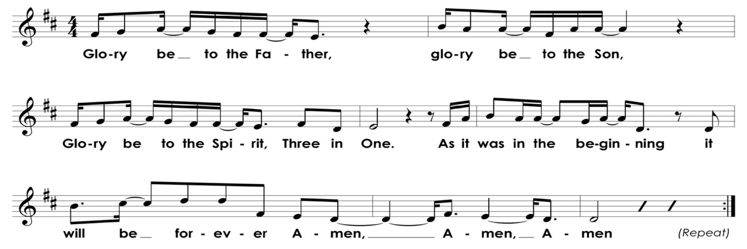
*Gloria Patri

*Affirmation of Faith Apostles' Creed
I believe in God the Father Almighty, Maker of heaven and earth, and in Jesus Christ his only Son our Lord; who was conceived by the Holy Ghost, born of the Virgin Mary, suffered under Pontius Pilate, was crucified, dead, and buried; He descended into hell; the third day He rose again from the dead; He ascended into heaven, and sitteth on the right hand of God the Father Almighty; from thence He shall come to judge the quick and the dead. I believe in the Holy Ghost; the holy catholic church; the communion of saints; the forgiveness of sins; the resurrection of the body; and the life everlasting. Amen.

BLESSING OF THE BACKPACKS

PRESENTATION OF TITHES AND OFFERINGS

Offertory Anthem “Prayer for Guidance” Allen Pote

Teach me your ways, make them known to me. Teach me to live according to your truth.
Because you are my savior, all day long I trust in you.
O remember your kindness and constant love which you have shown from long ago.
Forgive the sins and errors of my youth. Remember me, O Lord. --Psalm 25

*Doxology Old Hundredth
Praise God from whom all blessings flow, praise Him all creatures here below.
Praise Him above, ye heavenly host, praise Father, Son and Holy Ghost.

*Prayer of Dedication
Righteous God, it is within community that we are formed as Christians, disciplined and loved into being a holy people prepared to witness in word and work in the world. Bless us and these gifts we offer that your reign of justice tempered with mercy may come among all people of the earth. Amen.

Time for Children Sarah Craven
Litany of Parting
Children: May God be with you here. Congregation: May God be with you there.

*Hymn In My Life Lord, Be Glorified #300

Pastoral Prayer of the People
PROCLAIMING THE WORD

First Scripture Reading Jeremiah 23:23-29 Page 726

Second Scripture Reading Luke 12:49-56 Page 75

Sermon Looking Back, Living Forward

*Closing Hymn Rejoice, the Lord is King! #363

*Benediction and Choral Response Amen Roff

Postlude Prelude in F Fanny Mendelssohn Hensel

*Please stand, as you are able. Hearing aids and large-print hymnals are available at the back of the sanctuary.

INFORMATION/ANNOUNCEMENTS

SeCond family PrayerS – Allston Kitchens, Debra J. Gammons, David McEachern, Kay McGaha, Virginia Harding, Denise Girard, Paul Welborn, Winkie Welborn, Bill Thompson, Hope Staubes, Catherine Brack, Maria Fitzharris, and Courtney Waring.

BLESSING OF THE BACKPACKS – All students, teachers and other educators are encouraged to bring their bags to be prayed over for the new school year. Each person will receive a tag to place on their bag as a daily reminder of the love of God and their family at Second Pres. Immediately after the service we will celebrate with hotdogs, fruit and snow cones on the playground- everyone is welcome!

HOMECOMING SUNDAY – Join us September 8th for Homecoming Sunday. Our upcoming 1st, 3rd, 6th, 9th & 12th graders will be recognized in the service and everyone is invited to come together for lunch in the Fellowship Hall immediately following the worship service. Please contact Sarah if you have a child at a milestone age.

SUNDAY SCHOOL – Make plans to get to church for Sunday School beginning September 15th. Children (4&up) and Youth will be upstairs in the youth room, Young Adults & Families Sunday School will meet upstairs in the conference room, and The Mixed Adults class will continue to meet downstairs. The nursery will be available for children 3&under. Please contact Sarah with any questions.

SECOND EDITION BOOK CLUB – The choice for August’s Book Club discussion is Bread Wine and Chocolate by Simran Sethi - about taste, big agriculture and the decline in diversity of our food products. Our next meeting will be August 20th at 6:30 at Peter Rupert’s home at 1605 Cristalino Circle, Charleston, SC 29414. Please give him a heads-up as to attendance and what you may bring for supper by e-mail at yankee401@live.com.

PRIDE – A group will walk in the Charleston Pride Parade on Saturday, September 14th promoting love and unity for all God’s people. Registration is $15, which includes a “Seek Justice, Love Mercy, Walk Humbly + Welcome Everybody” church t-shirt and lunch after the parade at the church. Other participating congregations will be invited to the lunch and it will be open to the community, so the meal will be a wonderful time of fellowship. If you would be so called to join us on the walk, at the lunch, or through your support please sign up now! More information and sign up can be found at www.2ndpc.org/pride or contact Joshua Hall or Aled Pritchard.

HABITAT FOR HUMANITY – There are volunteer opportunities to join the Habitat build through October. Would you or your group like to join the “Faith Build”? For more information and to sign up go to www.2ndpc.org/blog/habitat or contact Sarah Mitchell (sarahscmitchell@gmail.com) or Sarah Stevens (smorton322@gmail.com).

DO YOU KNOW OF VOLUNTEER OPPORTUNITIES? We are putting together a comprehensive list of volunteer opportunities and while we know of many organizations with ties to members of Second, please reach out to let us know more about any organizations with which you are involved. Please contact Jordyn at jordyn.pritchard@2ndpc.org.
SUNDAY, August 18
Blessing of the Backpacks
10:00 a.m. – Mixed Adults Sunday School 11:15 a.m. – Worship Service
11:45 a.m. – Children’s Sunday School
12:15 p.m. – Deacon’s Meeting
MONDAY, August 19
TUESDAY, August 20
6:00 a.m. – Body Pump
7:30 p.m. – Young Professionals
WEDNESDAY, August 21
6:00 a.m. – Kickboxing
THURSDAY, August 22
6:00 a.m. – Body Pump
FRIDAY, August 23
SATURDAY, August 24
11:00 a.m. – Sisters in Serenity Group
SUNDAY, August 25
10:00 a.m. – Mixed Adults Sunday School 11:15 a.m. – Worship Service
11:45 a.m. – Children’s Sunday School
Looking ahead…

1st
2nd
3rd
3rd
3rd
3rd
5th
6th
6th
7th
7th
7th
8th
9th
9th
9th
11th
13th
14th
14th
15th
17th
20th
21st
21st
23rd
23rd
23rd
24th
24th
25th
25th
26th
26th
27th
28th
29th
30th
30th
31st

Bill Luhn
Sam Kerr
Beverly Bonner
Buckley Milner
Keaton Smith
Lucie Medbery
Stewart McKnight
Ava Ott
Felicia Sanders
Elliott Lipp
Charles James
Maria Fitzharris
Sara Elizabeth Craw
Erin Beam
Lily Walker
Lucas Beam
Mark McKnight
Cynthia La Roche
Carrie Luhn
Jeff Plotner
Joey Mosny
Carol Howe
Jim Driver
Edward Howe
Joel Dettweiler
Gus Smythe
Joshua Hall
SaSa Darwin
Clarissa Rider
Ralph Smith
David Savard
Walt Bonner
Leslie Hucks
Lily Darwin
James Driver
Laura Tucker
Ben Adams
Alison Schmidt
Edith Mellen
Sue Barnett

Charleston Pride Parade
Sunday 9:00 a.m.
September 14^{th,}
https://www.charlestonpride.org

FINANCIAL SNAPSHOT*

Cress Darwin, Pastor
cdarwin@2ndpc.org
Sarah Craven, Director of Christian Education, sarah.craven@2ndpc.org
Dr. Julia Harlow, Director of Music
jharlow@2ndpc.org
Lee Lingle, Chancel Choir Director
leelingle3@gmail.com
Suzann Lilienthal, Administrator
suzann.lilienthal@2ndpc.org
Jordyn Pritchard, Communications
jordyn.pritchard@2ndpc.org
Annie Ravenel, Housekeeping
Chuck Medbery, Elder of the Month
Gary Jaffe, Liturgist
Nicole Schuerman, Greeter
Sue Henderson, Director of Kindergarten
Erin Kerr, Asst. Director of Kindergarten

COMMITTEES
Aled Pritchard, Christian Education
Chuck Medbery, Finance
Sarah Mitchell, Missions
Nathan Walker, Music & Worship
Rob McCready, Property

 | Actual | Budget
Income | $241,806.39 | $286,762.53
Expenses | $293,884.71 | $332,045.39
 | -$52,078.32
Pledge Campaign | $257,618.00 | $270,000.00
Steeple Fund | $57,525.00 | $100,000
Thiele Fund
2019 Withdrawals | $51,000
Balance | $382,377.25
*As of August 13, 2019
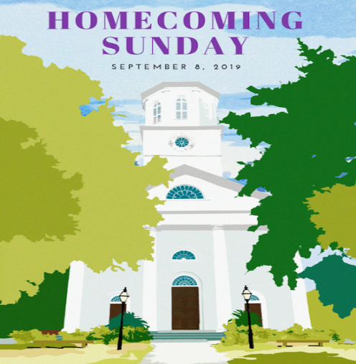

Second Presbyterian church 342 meeting street, Charleston, SC 29403 843.723.9237 WWW.2NDPC.ORG

