This is God's House; All are Welcome
“Meeting people at their point of need, Inviting all into a dynamic relationship with Christ”

Sunday, July 23, 2017 10:00 a.m.

When the music begins, worship begins.

Preservice Music Sanctuary

*Processional Hymn
Holy, Holy, Holy! Lord God Almighty! Early in the morning our song shall rise to Thee;
Holy, Holy, Holy! Merciful and mighty! God in three Persons, blessed Trinity.

WELCOME AND ANNOUNCEMENTS
Leader: This is the day the Lord hath made. Response: Let us rejoice and be glad in it!

GATHERING AROUND THE WORD

Prelude Will the Circle Be Unbroken A.P. Carter
Monique Middleton, soloist

*Call to Worship
Leader: Let us sing to God who blesses us abundantly.
People: O God, give light to our eyes.
Leader: Trust in God’s steadfast love; rejoice in God’s salvation.
People: God meets us here and answers our souls’ longings.

*Hymn O Worship the King #41

Invocation

The Lord’s Prayer (Unison)
Our Father, who art in heaven, hallowed be Thy name. Thy kingdom come, Thy will be done on earth as it is in heaven. Give us this day our daily bread and forgive us our trespasses as we forgive those who trespass against us. Lead us not into temptation, but deliver us from evil. For Thine is the kingdom, and the power, and the glory, forever. Amen.

CONFESSION OF SIN & ASSURANCE OF PARDON

Call to Confession
Merciful God, we humble ourselves before you today to confess the ways in which we have failed. We have fallen short of your call to welcome all your children, to include enemies and even those different than we are. You have called us to give the cup of cold water to even the least, but we look the other way. You know our hesitations God. You know our fears and doubts and selfish ways. Forgive us and give us courage to serve you in all our actions.

(A time of Silent Prayer)

Amen and Assurance of Pardon

*Gloria Patri Greatorex
Glory be to the Father, and to the Son, and to the Holy Ghost.
As it was in the beginning, is now and ever shall be World without end, Amen, Amen

*Affirmation of Faith Apostles' Creed
I believe in God the Father Almighty, Maker of heaven and earth, and in Jesus Christ His only Son our Lord; who was conceived by the Holy Ghost, born of the Virgin Mary, suffered under Pontius Pilate, was crucified, dead, and buried; He descended into hell; the third day He rose again from the dead; He ascended into heaven, and sitteth on the right hand of God the Father Almighty; from thence He shall come to judge the quick and the dead. I believe in the Holy Ghost; the holy catholic church; the communion of saints; the forgiveness of sins; the resurrection of the body and the life everlasting. Amen.

Time for Children Olivia Cappelmann

After the Children's Sermon, children in first grade and younger are invited to the

Education Building for a time of structured activity.

Hymn Sanctuary #701

Presentation of Tithes and Offerings
Offertory Anthem “Teach Me, O Lord” Thomas Attwood
Teach me, O Lord, the way of thy statutes; and I shall keep it unto the end. – Psalm 119:33

*Doxology Old Hundredth
Praise God from whom all blessings flow; Praise him all creatures here below;
Praise Him above ye heavenly host; Praise Father, Son and Holy Ghost. Amen.

*Prayer of Dedication
Gracious and holy God, as we make this offering to you this morning, help us to keep our lives focused on you. Remind us in the midst of our struggles, when we are feeling lost and forgotten, that we are not orphans, that we stand in the warmth of your love. Help us be inspired this day to take the good news of that love and the hope of Christ's resurrection beyond this church. Help us to reach people who desperately need to hear your words of hope and be touched by the strength of your compassion. In Christ's Holy name, we pray. Amen.

*Hymn God, Whose Giving Knows No Ending #716

Pastoral Prayer of the People

PROCLAIMING THE WORD

First Scripture Reading Luke 8:40-49 Page 68

Interlude The Blood Will Never Lose Its Power Andraé Crouch
Monique Middleton, soloist

Second Scripture Reading Hebrews 3:14 Page 220

Sermon Won’t Stop Can’t Stop Stephen Popadich

*Hymn Here I Am, Lord #69

Benediction

Postlude Come, Thou Fount of Every Blessing Words by Robert Robinson
Music from John Wyeth’s Repository of Sacred Music
Arr. by Randall Hartsell
*Please stand as you are able

INFORMATION/ANNOUNCEMENTS

Are you looking for a church home where you can make a difference for the God we serve, and a place where you will be known, nurtured, challenged? We welcome you and invite you to spend some time with us.

seCond family PrayerS – Delores King, Susanne Mclaughlin, Pat Mellen, Sue Henderson, Ora Singletary, Aaron Smith, grandson of Tammy Vermilling, Pat Garrett, Susan Harbin and Catherine Ann Suarez.

Guest preacher stephen popadich – Stephen Popadich is the leader of Young Adults at Seacoast Church. He has lived in Charleston now for four years with his wife Nicole and two children, Owen and Anacapri.

MEAL TRAIN - Help us stock the church freezer with meals that we can take, as needed, to church members who have lost a loved one, had a baby, been sick, had surgery, or are otherwise in need. Contact Liv at olivia.cappelmann@2ndpc.org for more information.

HANDS OF CHRIST - The mission of Hands of Christ is to bring PC(USA) congregations together to meet the basic needs of children by showing them Christ’s love, helping them start the school year with uniforms and basic school supplies. Started in 2002 by Zion-Olivet and Westminster Churches, the organization has supported over 48,000 school children in the Charleston area. This will be our third year serving as the Downtown Charleston distribution center on August 7th and 8th and you can find more information and the volunteer sign up at www.2ndpc.org/events. You can also help by collecting school supplies for the distribution through August 4th.

S.T.E.P.S. - As Christians, we have good news to share. This year’s theme, Be of Good Courage, will be expressed in many different ways. Join others in our presbytery Saturday, August 26th at Mount Pleasant Presbyterian Church. As you reflect on how you may grow in your Christian faith through experiences of worship, learning, fellowship, and service, consider some of the workshops available at S.T.E.P.S.: Cultivating a Healthier Church Culture, The Art of Kinsugi, Developing a Church Vision, Fear and the Creative Process, How the Sacraments Feed our Faith, Parenting in a Social Media Age, Adult Education Galore, Semper Reformanda- Always Being Reformed, Nurturing the God in You, to name a few. Go to the presbytery website www.capresbytery.org/steps to register or download a brochure.

Sponsor a chair - Three years ago we purchased 15 chairs for the choir loft. Many of these chairs have plaques commemorating their donation, in honor or memory of a specific individual, or given by a family. There are still several chairs without plaques and honorees. Please contact Dr. Harlow if you are interested in sponsoring a chair.

Habitat for humanity - Representatives from six congregations came together as one and as the community of faith in witness to God to help build this new home. How awesome! Thank you for your support and participation in this C-A Presbytery 'neighborhood' outreach mission. Our goal is for community mission activities, like this, to be the norm for our presbytery. Although our final scheduled work day has passed, building needs continue throughout the summer. Individuals or groups are invited to directly contact Anna Huie, volunteer coordinator for Sea Island Habitat (843-768-0998).

Haiti mission trip with Medical Benevolence Foundation - There is a mission opportunity to serve partners in Haiti with MBF. This trip is October 7–14 and MBF is extending an invitation to those at Second Pres to join this trip to serve partners in Haiti. If you are unable to go on the trip you can still participate by being a “Sender”! Senders pray for and encourage others as they prepare for the trip and as they serve. Senders are critical to the success of any mission trip. Visit www.mbfoundation.org for more information.

LOOKING AHEAD...

SUNDAY, July 23
9:30 a.m. – Adult Choir Rehearsal
10:00 a.m. – Worship in the Sanctuary
Guest Preacher Stephen Popadich
MONDAY, July 24
TUESDAY, July 25
7:00 p.m. – Spiritual Ensemble Rehearsal
7:30 p.m. - Young Professionals (West Ashley)
WEDNESDAY, July 26
6:00 a.m. - Kickboxing
THURSDAY, July 27
7:00 p.m. –Young Professionals (Downtown)
FRIDAY, July 28
SATURDAY, July 29
11:00 a.m. - Sisters in Serenity Group
SUNDAY, July 30
9:30 a.m. – Adult Choir Rehearsal
10:00 a.m. – Worship in the Sanctuary
Guest Preacher Manfred Brauch

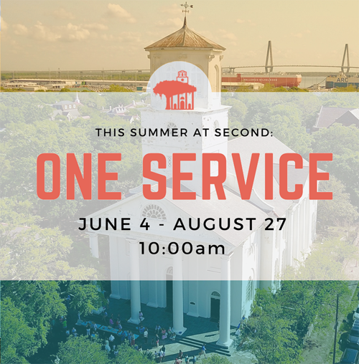

1st Hyliah Burroughs
4th Ken Carrington
4th Greta Howe
5th Rebecca Darwin
5th Charles Hucks
5th Sallie Schuh
5th Ora Singletary
8th Brittany-Lee Baumer
8th Edmund Most
8th Georgie Smythe
9th Daniel Schmidt
10th Majorie Hamlin
12th Ruth Carr
12th Kay McGaha
13th Meredith Bird
15th Sharon Hoffman
15th Nathan Senn
18th James Lipp
19th Gary Jaffe
19th Gene McMurray
21st Meredith Mosny
22nd Jackson Markiewiez
22nd Isabelle Smythe
24th Shateara Hall
24th Zac Magnell
25th Katherine King
26th Alexander McNulty
27th Cathy Hinson
28th Charlotte Craw
28th Stockton Jacobs
2nd Sam Kerr

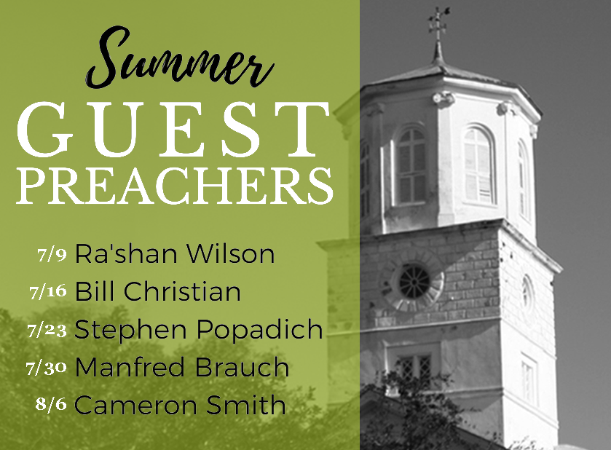

Cress Darwin, Pastor
cdarwin@secondpresbyterianchurch.org
Dr. Julia Harlow, Director of Music
jharlow@2ndpc.org
Olivia Cappelmann, Director of Youth & Christian Education olivia.cappelmann@2ndpc.org
Colin Kerr, Director of Campus &
Young Adult Ministry
charlestonjourney@gmail.com
Suzann Lilienthal, Administrator
suzann.lilienthal@2ndpc.org
Jordyn Pritchard, Communications
jordyn.pritchard@2ndpc.org
Holly Slice, Director of Chapel Music
Annie Ravenel, Housekeeping
Melvin Kizer, Church Sexton
Peter Rupert, Head Usher
Sarah Morton, Liturgist
A.J. Manett, Elder of the Month
Dawn Mears, Greeter
Sue Henderson, Director of Kindergarten
Erin Kerr, Asst Director of Kindergarten

\
Studying + Teaching + Equipping + Praying + Serving: This presbytery-wide event is a wonderful opportunity for high school youth and adult church members, teachers, ministry teams, worship/music leaders, officers and staffs to enrich their faith and understanding of the church. S.T.E.P.S. will take place Saturday, August 26th at Mount Pleasant Presbyterian. Pre-registration deadline is August 10th.

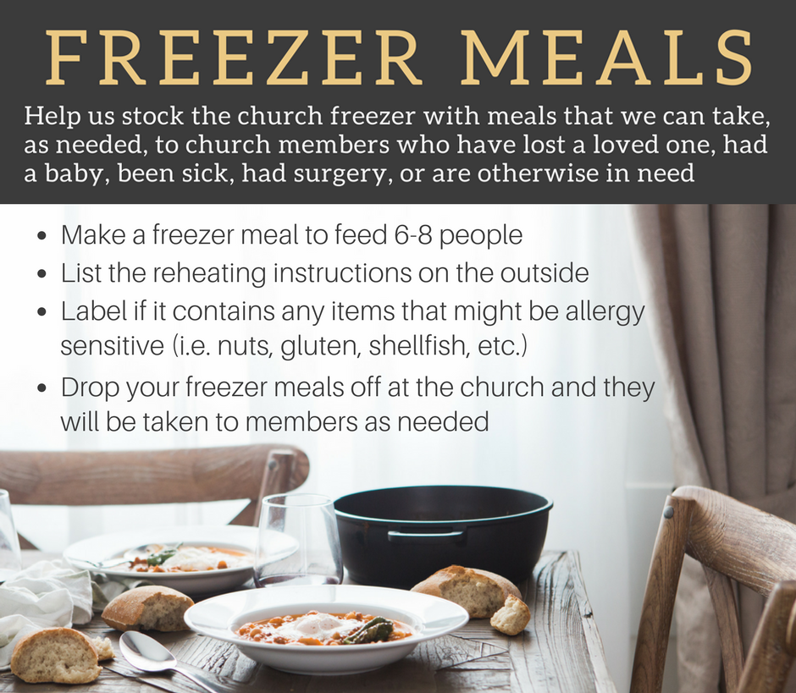

Distribution days for Hands of Christ here at Second Pres are August 7th and 8th. School supplies for the distribution will be collected through August 4th. Find more information and the volunteer sign up link at www.2ndpc.org/events.

