This is God's House - All are Welcome

“Meeting people at their point of need, Inviting all into a dynamic relationship with Christ”

June 17, 2018 10:00 a.m.

Today’s flowers are given by Ralph and Tina Smith in celebration of their 46th anniversary

Prelude Hymn Stylings Dan Coates

*Processional Hymn
Holy, Holy, Holy! Lord God Almighty! Early in the morning our song shall rise to Thee;
Holy, Holy, Holy! Merciful and mighty! God in three Persons, blessed Trinity.

WELCOME AND ANNOUNCEMENTS
Leader: This is the day the Lord hath made. Response: Let us rejoice and be glad in it!

GATHERING AROUND THE WORD
Call to Worship Psalm 63:1-4, 7-8
Leader: O God, you are my God; eagerly I seek you;
People: My soul thirsts for you, my flesh faints for you, as in a barren and dry land where
there is no water.
Leader: Therefore I have gazed upon you in your holy place, that I might behold your
power and your glory.
People: For your loving-kindness is better than life itself; my lips shall give you praise.
Leader: So I will bless you as long as I live and lift up my hands in your name.
People: For you have been my helper, and under the shadow of your wings I will rejoice.
Leader: My soul clings to you; your right hand holds me fast.
People: O God, you are our God; eagerly we seek you.

*Hymn As the Deer Pants for the Water/ I Love You, Lord #626, 627

Invocation

Lord's Prayer (Unison)
Our Father, who art in heaven, hallowed be Thy name. Thy kingdom come, Thy will be done on earth as it is in heaven. Give us this day our daily bread and forgive us our trespasses as we forgive those who trespass against us. Lead us not into temptation, but deliver us from evil. For Thine is the kingdom, and the power, and the glory, forever. Amen.

CONFESSION OF SIN & ASSURANCE OF PARDON
Call to Confession Based upon Psalm 40
Do not withhold your mercy from us, Lord; may your love and truth always protect us. For troubles surround us, our sins overtake us, and we cannot see. Be pleased, Lord, to save us; come quickly to help us. May all who seek you rejoice and be glad in you. May we always say, “The Lord be exalted!” Yet, we are poor and needy. You are our help and our deliverer; O God, do not delay.

Silent Confession and Assurance of Pardon
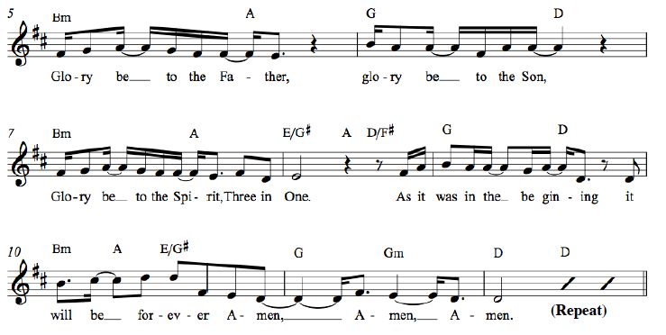
*Gloria Patri

*Affirmation of Faith Apostles' Creed
I believe in God the Father Almighty, Maker of heaven and earth, and in Jesus Christ His only Son our Lord; who was conceived by the Holy Ghost, born of the Virgin Mary, suffered under Pontius Pilate, was crucified, dead, and buried; He descended into hell; the third day He rose again from the dead; He ascended into heaven, and sitteth on the right hand of God the Father Almighty; from thence He shall come to judge the quick and the dead. I believe in the Holy Ghost; the holy catholic church; the communion of saints; the forgiveness of sins; the resurrection of the body; and the life everlasting. Amen.

PRESENTATION OF TITHES AND OFFERINGS
Offertory Anthem “Like As a Father” Luigi Cherubini

Like as a father, filled with compassion pities all his children,
so the Lord hath mercy on those that fear Him. Psalm 103

*Doxology

Praise God from whom all blessings flow; Praise Him all creatures here below;

Praise Him above ye heavenly host; Praise Father, Son and Holy Ghost. Amen.

*Prayer of Dedication
God, your mercy, compassion, and peace is extended to the whole world. We have been charged with the task of sharing this truth. We bring this offering as pledge of our response to your call to spread the gospel, and to this end we dedicate it in you. Amen.

Time for Children Ken Carrington
All children are invited forward and those first grade and younger
may go to the Education Building for a time of structured activity.

*Hymn For the Fruit of All Creation #36

Pastoral Prayer of the People

PROCLAIMING THE WORD

First Scripture Reading Ezekiel 17:22-24 Page 784

Second Scripture Reading Mark 4:26-34 Page 38

Sermon Living Into Your Call, Not Your Can Rev. Cress Darwin

*Closing Hymn Lord, Dismiss Us With Your Blessing #546

Benediction

Postlude Variations to the Sicilian Hymn Benjamin Carr

*Please stand, as you are able. Hearing aids and large-print hymnals are available at the back of the sanctuary.

INFORMATION/ANNOUNCEMENTS

Are you looking for a church home where you can make a difference for the God we serve, and a place where you will be known, nurtured, challenged? We welcome you and invite you to spend some time with us.

seCond family PrayerS – Jim Scott, son-in-law of Dolly Hamlin; Pat Garrett, Laura Denman, Sue Henderson, and Courtney Waring.

SIGN UP TODAY FOR VBS – Vacation Bible School is June 24th-28th from 5:30-8:00pm hosted along with Redeemer Presbyterian here at Second Presbyterian. Volunteers and participants can sign up now through June 17th. There are many ways to serve: you can volunteer to teach, lead, provide supplies from our Amazon Wish List, or help with the meals. Find registration forms, a link to the Wish List, and more information at 2ndpc.org/vbs.

donate supplies FOR VBS – Consider contributing, if you can, with a donation of any of the supplies on the Amazon Wish List, found at amzn.to/2khByuq or via 2ndpc.org/blog/vbs. It will be greatly appreciated and will directly provide for this exciting and important community event.

SECOND EDITION BOOK CLUB – Next month we'll hike light-heartedly through England in The Road to Little Dribbling with author Bill Bryson. Here he revisits some 20 years later his favorite haunts of prior years throwing in entertaining sidelights of English history. Many of us are away in June, so we will next meet at the Schuh’s, 655 North Shore Drive, at 6:30 on Tuesday, July 18th.

HANDS OF CHRIST – The Hands of Christ school clothing and supplies event (August 13th & 14th here at Second) needs our members to help- both at our church and at other sites. We will need folks to unload the truck Monday, set up the rooms, and be shopping helpers to go around with each child. Very importantly, Hands of Christ staff will be training some of our members to work with registering the families as they arrive. This will be our fourth year serving as the Downtown Charleston Distribution Center.

Sponsor a chair – A few years ago we purchased 15 chairs for the choir loft. Many of these chairs have plaques commemorating their donation, in honor or memory of a specific individual, or given by a family. There are still chairs without plaques and honorees. Please contact Dr. Harlow if you are interested in sponsoring a chair.

MEAL TRAIN – Help us stock the church freezer with meals that we can take, as needed, to church members who have lost a loved one, had a baby, been sick, had surgery, or are otherwise in need.

greeters and ushers are needed on Sunday mornings. No special experience necessary! Email Tina, skippytsmith@gmail.com, for more information. Sign up quickly and easily at www.2ndpc.org/signup

AMAZON SMILE – You can support Second Pres when you shop on Amazon. Use the link: bit.ly/2ndpcsmile or choose to support “Second Presbyterian Church” at smile.amazon.com and Amazon will automatically donate to Second Presbyterian with each purchase you make.

Looking ahead…
SUNDAY, June 17
10:00am – Worship Service
MONDAY, June 18
TUESDAY, June 19
6:00am – Body Pump
Spiritual Ensemble on summer break
7:30pm – Young Professionals (West Ashley)
WEDNESDAY, June 20
6:00am – Kickboxing
THURSDAY, June 21
6:00am – Body Pump
7:00pm – Young Professionals (Downtown)
FRIDAY, June 22
SATURDAY, June 23
11:00am – Sisters in Serenity Group
SUNDAY, June 24
10:00am – Worship Service
5:30pm – Vacation Bible School

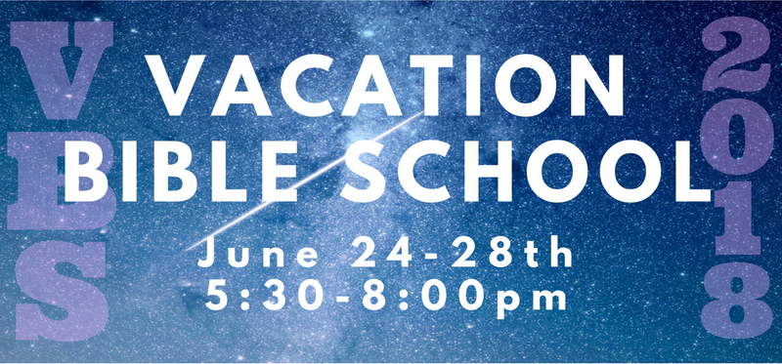

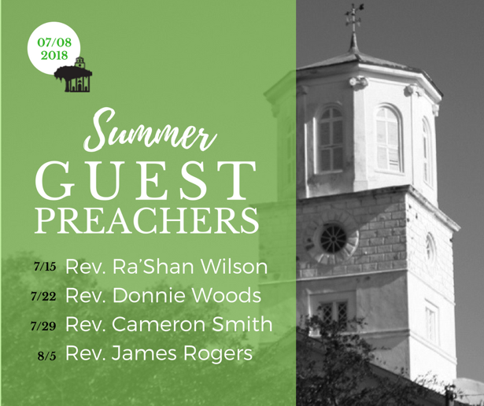

Jeanne McBride
Ann Gustafson
Greg Ricker
Reid McElwaine
Claire Curran
Debra Luhn
Helen Smythe
Dolores King
Lauriel Snyder
Dingle Howe
Lynn Lind
Melinda Accardo
Peggy Hay
Courtney King
Barnaby Henderson
Sue Henderson
Patterson Smith
Susan Sanders
Ciara Fitzharris
Sean Fitzharris
Phyllis McGillivray
Blair Pritchard
Penelope Pritchard
Sherri Jacobs
Samuel Almeida
Sarah Girard
Cynthia Marterre
Sally McDuffie
Taylor Powell
Craig Ramsdell
Barnes Plotner
Benjamin Taylor
Judson Plotner
Robert McCready
Erin Mellen
Debbie Smith
1st
3rd
3rd
6th
7th
7th
7th
10th
11th
12th
13th
14th
15th
15th
18th
18th
18th
19th
20th
20th
20th
20th
20th
21st
22nd
23rd
23rd
23rd
24th
24th
26th
26th
28th
30th
30th
30th

Cress Darwin, Pastor
cdarwin@2ndpc.org

Dr. Julia Harlow, Director of Music
jharlow@2ndpc.org

Tim Thompson, Chapel Music Director

Lee Lingle, Chancel Choir Director

Olivia Cappelmann, Director of Youth & Christian Education olivia.cappelmann@2ndpc.org

Suzann Lilienthal, Administrator
suzann.lilienthal@2ndpc.org

Jordyn Pritchard, Communications
jordyn.pritchard@2ndpc.org

Annie Ravenel, Housekeeping

Brad Milner, Elder of the Month

Patterson Smith, Liturgist

Nicole Schuerman, Greeter

Sue Henderson, Director of Kindergarten

Erin Kerr, Asst Director of Kindergarten

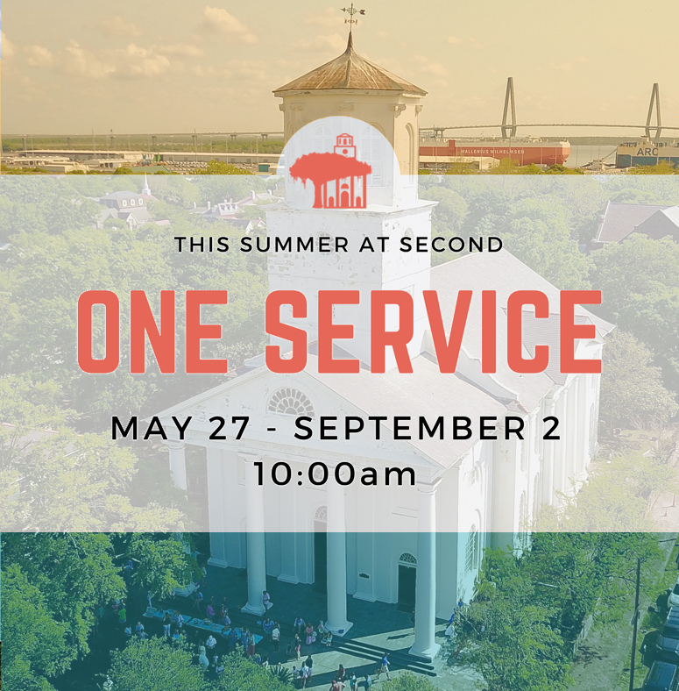

Second Presbyterian church 342 meeting street, Charleston, sc 29403 843.723.9237 www.2ndpc.org

