This is God's House - All are Welcome
“Meeting people at their point of need, Inviting all into a dynamic relationship with Christ”

Sunday, May 20, 2018 9:30 a.m.
Pentecost

*Congregation please stand and sing:

Holy, Holy, Holy! Lord God Almighty! Early in the morning our song shall rise to Thee;

Holy, Holy, Holy! Merciful and mighty! God in three Persons, blessed Trinity!

Minute for Missions

GATHERING AROUND THE WORD
*Call to Worship
Leader: "My thoughts are not your thoughts, nor are your ways my ways, says the Lord.
People: "For as the heavens are higher than the earth, so are my ways higher than your ways, and my thoughts than your thoughts" (Isa 55:8-9).
Leader: Let us humble ourselves before God, that our thinking may be enlightened and our doing directed by the one who made every person, and who knows and loves us all. Come, let us worship God.

*Hymn Come, Holy Spirit, Heavenly Dove GG #279

Invocation

Lord's Prayer Unison
Our Father, who art in heaven, hallowed be Thy name. Thy kingdom come Thy will be done on earth as it is in heaven. Give us this day our daily bread and forgive us our trespasses as we forgive those who trespass against us. Lead us not into temptation, but deliver us from evil. For Thine is the kingdom, and the power, and the glory forever. Amen.

CONFESSION OF SIN & ASSURANCE OF PARDON
Call to Confession Unison
Holy God, we confess that we confuse pious morality with the kind of righteousness that is your will and your way. We judge others, even ourselves, by standards we have set with our limited understanding of who you are and of your eternal purposes. We want to believe we are good and faithful people, yet we set ourselves apart from those we deem to be unrighteous. Forgive us when we turn inward. Forgive us when we fail to love as you loved, and when we fail to welcome into our fellowship those whom you would welcome. Forgive us when we are unable or unwilling to see and honor the courage, endurance, longing, the need for acceptance, and the love in those whom we may neglect or reject, but whom you call beloved brothers and sisters.

(A time of Silent Prayer)

Amen / Assurance of Pardon

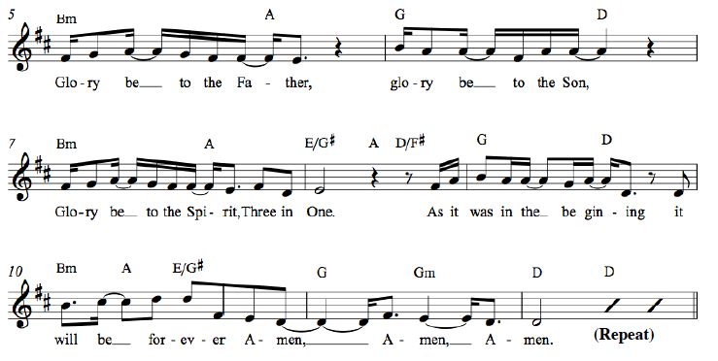
*Gloria Patri

*Affirmation of Faith Apostles’ Creed
I believe in God the Father Almighty, Maker of heaven and earth, and in Jesus Christ his only Son our Lord; who was conceived by the Holy Ghost, born of the Virgin Mary, suffered under Pontius Pilate, was crucified, dead, and buried; he descended into hell*; the third day he rose again from the dead; he ascended into heaven, and sitteth on the right hand of God the Father Almighty; from thence he shall come to judge the quick and the dead. I believe in the Holy Ghost; the holy catholic** Church; the communion of saints; the forgiveness of sins; the resurrection of the body; and the life everlasting. Amen.
* ”hell” refers to the Hebrew word “Sheol,” a place of the dead, rather than the Hell of the final judgment.
** “catholic” is Latin for “universal,” implying the Christian unity that exists beyond all denominations.

*Hymn Like the Murmur of the Dove’s Song GG #285

Welcome and Announcements
Leader: This is the day the Lord hath made. Response: Let us rejoice and be glad in it!
(at the beginning of the announcements the children are invited to go to Sunday School)

Presentation of our Gifts
*Doxology (Please sing together, as we give our tithes and offerings.)

Praise God from whom all blessings flow, Praise him all creatures here below.
Praise Him above ye heavenly hosts, Praise Father, Son and Holy Ghost.
To God all honor, to God all praise, to God all glory, forever more, Amen. (2x)

Pastoral Prayer of the People

PROCLAIMING THE WORD

First Scripture Reading Psalm 68:1-10 OT Page 529

Musical Reflection

Second Scripture Reading John 17:6-19 NT Page 111

Sermon Red Letter Christians Rev. Cress Darwin

*Hymn Every Time I Feel the Spirit GG #66

Prayer for Illumination and Understanding

Questions about the Sermon Raise your hand or text to (843) 608-8447

*Benediction
*Please stand as you are able

INFORMATION/ANNOUNCEMENTS
Are you looking for a church home where you can make a difference for the God we serve, and a place where you will be known, nurtured, challenged? We welcome you and invite you to spend some time with us.

seCond family PrayerS – Glendale Terry, brother of Felicia Sanders; Pat Garrett, Laura Denman, Sue Henderson, Tim Thompson, and Courtney Waring.

pentecost Offering – Each year on Pentecost Sunday, we celebrate the gift of the Holy Spirit and the birthday of the church. The Holy Spirit remains with us still, connecting us with the church of the past, continuing to inspire the church of today, and pointing us to the church of the future. By giving to the Pentecost Offering today, we are nurturing the faith of those who are the church to come; children, youth, and young adults. We invite you to join with the worldwide church in building for our future, in building individual lives of faith. 40% of the offering will be used here at Second for the community-wide Vacation Bible School.

ONE SUMMER SERVICE – Joint Summer Service at 10am begins next Sunday, May 27th.

liturgists, greeters, and ushers are needed on Sunday mornings. No special experience necessary! Email Tina, skippytsmith@gmail.com, for more information. Sign up quickly and easily at www.2ndpc.org/signup

Collecting quarters – On Tuesday, May 29th the West Ashley Young Adult Small Group is hosting a Free Laundry Night at Loving America Street’s Laundry Matters. The group needs your help collecting quarters to help our neighbors on the eastside do laundry for their families. There will be buckets located around the church campus. Please drop in a few extra quarters if you can. Thanks for your support of this amazing ministry.

Tea Room – Join us May 25th, 26th & 27th, from for lunch, cake & tea to benefit our missions program. Staff volunteers are needed Friday & Saturday from 10-2:30 and Sunday from 10-3:30 and for a Prep Day May 24th from 10-3pm. Volunteers needed, on Saturday & Sunday especially, for staff, prep, and baking desserts. Please consider your contribution to Tea Room by volunteering your time in some way. We would love to see you there enjoying our delicious fare- and spread the word to family & friends to join us for FUN, FOOD & FELLOWSHIP! It’s not too late to sign up! Contact Cathy at bluesdog2@att.net so she can get you on the schedule.

SIGN UP now FOR VBS – Vacation Bible School will be June 24th-28th from 5:30-8:00pm. Volunteers and participants can sign up now. There are many ways to serve: you can volunteer to teach, lead, provide supplies from our Amazon Wish List, or help with the meals. Find registration forms, a link to the Wish List, and more information at 2ndpc.org/blog/vbs.

PICCOLO SPOLETO – Youth Music Festival concerts will be held in our sanctuary on Sunday, May 27th beginning at 1:30pm. There will be several 45 minute long concerts from this series featuring school age artists and ensembles. Admission is free, donations welcome. Check www.2ndpc.org/music for more detailed information. On Saturday May 26th at 6:30pm St. Andrew’s Presbyterian in West Ashley will also be hosting Piccolo Spoleto. This free event at one of our neighborhood churches will feature Philip Lipton, Charleston native composer and performer premiering his life works for clarinet and bass clarinet.

AMAZON SMILE – You can support Second Pres when you shop on Amazon. Use the link: bit.ly/2ndpcsmile, or choose to support “Second Presbyterian Church” at smile.amazon.com and Amazon will automatically donate to Second Presbyterian with each purchase you make.

Looking ahead…
SUNDAY, May 20
9:30am – Chapel Service
10:00am – Sunday School
11:15am – Sanctuary Service
MONDAY, May 21
TUESDAY, May 22
6:00am – Body Pump
7:00pm – Spiritual Ensemble Rehearsal
7:30pm – Young Professionals (West Ashley)
WEDNESDAY, May 23
6:00am – Kickboxing
5:30pm – Bell Choir Rehearsal
6:30pm – Choir Rehearsal
THURSDAY, May 24
6:00am – Body Pump
7:00pm – Young Professionals (Downtown)
FRIDAY, May 25
11:00am – Tea Room
SATURDAY, May 26
11:00am – Tea Room
11:00am – Sisters in Serenity Group
SUNDAY, May 27
10:00am – One Summer Worship Service
(Tea Room serving members after worship)
11:45am – Tea Room (open to public)
1:30pm – Piccolo Spoleto Youth Music Festival

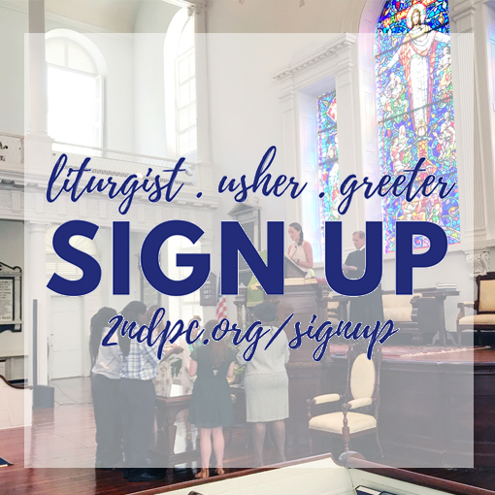
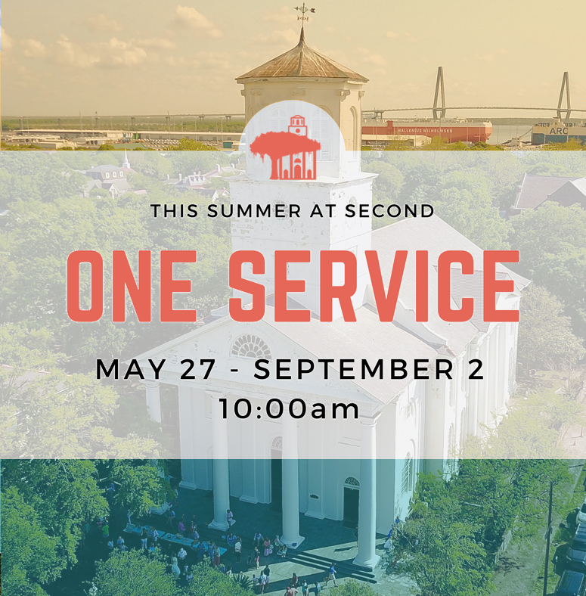

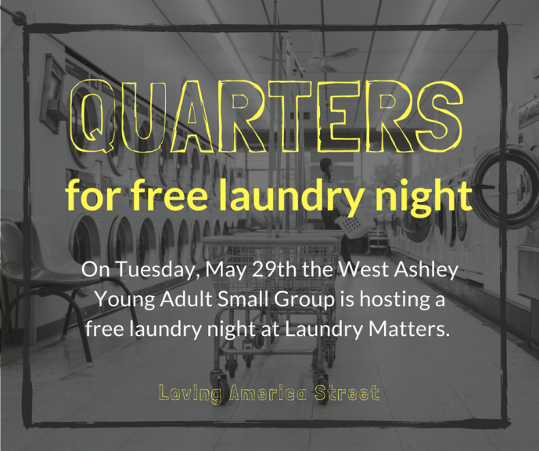

Cress Darwin, Pastor
cdarwin@2ndpc.org
Dr. Julia Harlow, Director of Music
jharlow@2ndpc.org
Tim Thompson, Chapel Music Director
Lee Lingle, Chancel Choir Director
Olivia Cappelmann, Director of Youth & Christian Education olivia.cappelmann@2ndpc.org
Colin Kerr, Director of Campus &
Young Adult Ministry charlestonjourney@gmail.com
Suzann Lilienthal, Administrator
suzann.lilienthal@2ndpc.org
Jordyn Pritchard, Communications
jordyn.pritchard@2ndpc.org
Annie Ravenel, Housekeeping
Jerald Hucks, Elder of the Month
Jerald Hucks, Liturgist
Hucks family, Greeter
Sue Henderson, Director of Kindergarten
Erin Kerr, Asst Director of Kindergarten

Ann Hackett
Liz McNulty
Marion Mitchell
Elizabeth O'Quinn
Zach Wright
Karen Freeman
Susanne McLaughlin
Dawn Mears
Mark Saunders
Tripp Accardo
Carolyn Jenkins
Walt Jeter
Benjamin Street
Trip Carrington
Clay Brock
Bill McLean
Burke Lackey
Isabelle Burroughs
Margaret Fleming
Allyson Hiers
Cody Baumer
Patrick McNulty
Bud Hay
Cassie Jaffe
Carter Fox
Ivey Jeter
Katherine Albright
Matt Richert

1st
1st
2nd
3rd
3rd
4th
5th
5th
5th
6th
6th
9th
9th
10th
11th
14th
16th
21st
21st
22nd
23rd
23rd
24th
24th
25th
28th
31st
31st

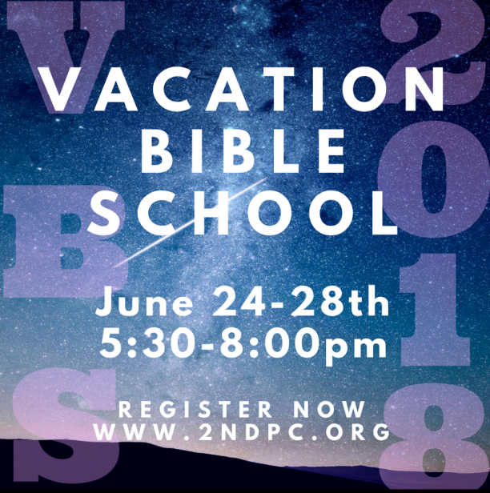

C

Second Presbyterian church 342 meeting street, Charleston, sc 29403 843.723.9237 www.2ndpc.org

