This is God's House - All are Welcome
“Meeting people at their point of need, Inviting all into a dynamic relationship with Christ”

May 19, 2019 FIFTH SUNDAY OF EASTER 11:15 a.m.

Preservice Music "Wholly Holy" Trad. arr. A. Franklin
Charleston Gospel Choir
Jennifer Ancrum, Director

Wholly holy, come together, People we've got to come together because we need the strength,
the power and all of the feeling. We should believe in each other's dreams. We can conquer things forever.
Jesus left a long time ago, said he would return, he left us a book to believe in.

*Processional Hymn:
Holy, Holy, Holy! Lord God Almighty! Early in the morning our song shall rise to Thee;
Holy, Holy, Holy! Merciful and mighty! God in three Persons, blessed Trinity.

WELCOME AND ANNOUNCEMENTS
Leader: This is the day the Lord hath made. Response: Let us rejoice and be glad in it!

Prelude "On Our Way" Trad. arr. A. Franklin
We're on our way to a land of endless day. We're on our journey home.
When we get to glory we will shout and tell the story how we made it over.

GATHERING AROUND THE WORD
*Call to Worship (inspired by John 13:34-35)
Leader: Jesus has given us a new commandment:
People: We are commanded to love one another.
Leader: Just as Christ has loved us,
People: So we ought to have love for one another.
Leader: By this, everyone will know we are Christ’s disciples:
People: By our love for one another.
Leader: Come, may we join our hearts in worship:
People: Worship God by loving one another.
~ written by Rev. Mindi and posted on Rev-o-lution. http://rev-o-lution.org/

*Hymn We Are One in the Spirit (They’ll Know We Are Christians) #300

Invocation

Lord's Prayer (Unison)
Our Father, who art in heaven, hallowed be Thy name. Thy kingdom come, Thy will be done on earth as it is in heaven. Give us this day our daily bread and forgive us our trespasses as we forgive those who trespass against us. Lead us not into temptation, but deliver us from evil for thine is the kingdom and the power and the glory forever. Amen.

CONFESSION OF SIN & ASSURANCE OF PARDON
Call to Confession (Unison)
Almighty God, you love us, but we have not loved you; you call, but we have not listened. We walk away from neighbors in need, wrapped up in our own concerns. We have gone along with evil, with pride, quarrelling, and divisiveness. Holy God, help us to face up to ourselves, so that, as you move toward us in mercy, we may repent, turn to you, and receive mercy; through your name. Amen.
~inspired by Matthew 22:37-39, Mark 12:31, posted on the PCUSA website. http://www.pcusa.org/

Silent Confession and Assurance of Pardon

*Gloria Patri Greatorex
Glory be to the Father, and to the Son and to the Holy Ghost.
As it was in the beginning, is now and ever shall be. World without end, Amen, Amen.

*Affirmation of Faith Apostles' Creed
I believe in God the Father Almighty, Maker of heaven and earth, and in Jesus Christ his only Son our Lord; who was conceived by the Holy Ghost, born of the Virgin Mary, suffered under Pontius Pilate, was crucified, dead, and buried; He descended into hell; the third day He rose again from the dead; He ascended into heaven, and sitteth on the right hand of God the Father Almighty; from thence He shall come to judge the quick and the dead. I believe in the Holy Ghost; the holy catholic church; the communion of saints; the forgiveness of sins; the resurrection of the body; and the life everlasting. Amen.

PRESENTATION OF TITHES AND OFFERINGS

Offertory Anthem "What a Friend We Have in Jesus" Trad. arr. A. Franklin
What a friend we have in Jesus, all our sins and griefs to bear.
What a privilege it is to carry everything to God in prayer.
O what peace we often forfeit, o what needless pain we bear.
All because we just don't carry everything to God in prayer.

*Easter Doxology sung to 'Lasst uns erfreuen'
Praise God from whom all blessings flow, praise Him all creatures here below. Alleluia! Alleluia!
Praise Him above, ye heavenly host, praise Father, Son and Holy Ghost. Alleluia! Alleluia!

*Prayer of Dedication
God, we are commissioned to tell the lonely of your companioning presence, to speak to the sick in body or soul of your healing love, and to testify to the reality of hope for the hungry and homeless in practical ways. Use us and use these gifts, that relief, release and justice may be proclaimed in the world by your Spirit. Amen.

Time for Children Sarah Craven
Litany of Parting
Children: May God be with you here. Congregation: May God be with you there.

*Hymn Good Christians All, Rejoice and Sing! #239

Pastoral Prayer of the People

PROCLAIMING THE WORD

First Scripture Reading Revelation 21:1-6 Page 259

Second Scripture Reading Acts 11:1-18 Page 130

Sermon NO DISTINCTIONS Rev. Cress Darwin

*Closing Hymn Soon and Very Soon #384

*Benediction

Choral Postlude "How I Got Over" Clara Ward, arr. A. Franklin
You know that my soul looks back and wonders how I got over. Just as soon as I see Jesus the man who made me free,
He was the man that bled and suffered, He died for you and for me. I wanna thank Him because He brought me,
because He taught me. I will thank God because He kept me, because he never left me.
I'm gonna sing. I might shout this evening, I'm gonna thank Jesus for all He's done for me.

CONGREGATIONAL MEETING

*Please stand, as you are able. Hearing aids and large-print hymnals are available at the back of the sanctuary.

INFORMATION/ANNOUNCEMENTS

Are you looking for a church home where you can make a difference for the God we serve, and a place where you will be known, nurtured, challenged? We welcome you and invite you to spend some time with us.

SeCond family PrayerS – Virginia Harding, Delores King, Denise Girard, Paul Welborn, Winkie Welborn, Bill Thompson, Hope Staubes, Catherine Brack, Maria Fitzharris, and Courtney Waring.

TODAY'S MUSIC: We welcome today members of the Charleston Gospel Choir, directed by Jennifer Ancrum. All of the arrangements sung today were done by Aretha Franklin (1942-2018). They were performed at Charleston Gospel Choir’s recent concert: "Queen of Soul and Gospel: A Tribute to Aretha Franklin". From her time growing up as the daughter of a prominent African-American preacher to her death this past August, Franklin was immersed and involved in the struggle for civil rights and women's rights. Her songs "Respect" and "Natural Woman" in particular became anthems of these movements for social change. Charleston Gospel Choir makes its home here at Second and sings twice yearly in our services.

CONGREGATIONAL MEETING – The suspended portions of the April 28th Annual Meeting of the Congregation and the Corporation of the Second Presbyterian Church will continue after the service today, May 19th at 12:30 p.m. in the Sanctuary to elect the Elder Class of 2022 and the Nominating Team members 2021-2022.

BOOK CLUB – This Tuesday, May 21st the book club will meet to discuss Where the Crawdads Sing by Delia Owens. Potluck meeting, as usual, at Peter Rupert's, 1605 Cristalino Circle, Carolina Bay, 29414.

TEA ROOM THIS WEEK – Join us May 24th, 25th & 26th for lunch and dessert to benefit our Missions program. Friday & Saturday from 11:00 - 2:00 p.m. and Sunday from 12:30 - 3:00 p.m. Everyone is welcome.

NEXT SUNDAY, MAY 26: Piccolo Spoleto Youth Music Festival: Charleston Children's Chorus, 1:00 p.m.; Girls' Choir of Wilmington, 2:00 p.m.; Harmonia Children's Choir (Mt. Pleasant), 3:00 p.m.; Goose Creek High School Chamber Choir, 4:00 p.m.

SPOTLIGHT SERIES – Concerts at 6:00 p.m. unless otherwise noted: May 28th- Fantasma: Piano Trio; May 29th- The In Between: Jazz and poetry; May 30th- CSO Strings Rejoice; May 31st- Chamber Music Charleston; June 1st C of C Concert Choir at 12:00 p.m. and CSO Brass and Organ at 5:00 p.m.; June 3rd- Hello Saxophone!; June 4th- Carol Gimbel, viola; June 5th- Leah Edwards and Dimitri Pittas, vocals; June 6th- Charleston Piano Trio.

FIRST WEDNESDAY MEN’S LUNCH – Men from neighborhood churches come together at noon in the St. Philip's Parish Hall (on the corner of Church and Cumberland) on the first Wednesday of the month for food and fellowship. The June speaker is Richard Grimball and this will be the last lunch before a summer break.

SUNDAY, May 19

10:00 a.m. – Mixed Adult Sunday School
11:15 a.m. – Worship Service

11:45 a.m. – Children’s Sunday School
12:30 p.m.– Congregational Meeting
MONDAY, May 20
TUESDAY, May 21
6:00 a.m. – Body Pump
5:30 p.m. – Spiritual Ensemble Rehearsal
6:30 p.m. – Book Club
7:30 p.m. – Young Professionals
WEDNESDAY, May 22
6:00 a.m. – Kickboxing
5:00 p.m. – Bell Choir
6:00 p.m. – Financial Peace University
6:30 p.m. – Adult Choir
THURSDAY, May 23
6:00 a.m. – Body Pump
10:00 a.m. - Tea Room Prep Day
FRIDAY, May 24
11:00 a.m. – Tea Room
SATURDAY, May 25
11:00 a.m. – Sisters in Serenity Group
11:00 a.m. – Tea Room
SUNDAY, May 26

11:15 a.m. – Worship Service

11:45 a.m. – Children’s Sunday School
12:30 p.m. – Tea Room
Piccolo Spoleto Youth Music Festival
1:00 p.m. – Charleston Children’s Chorus
2:00 p.m. – Girls’ Choir of Wilmington
3:00 p.m. – Harmonia Children’s Choir
4:00 p.m. – Goose Creek High School
Chamber Choir
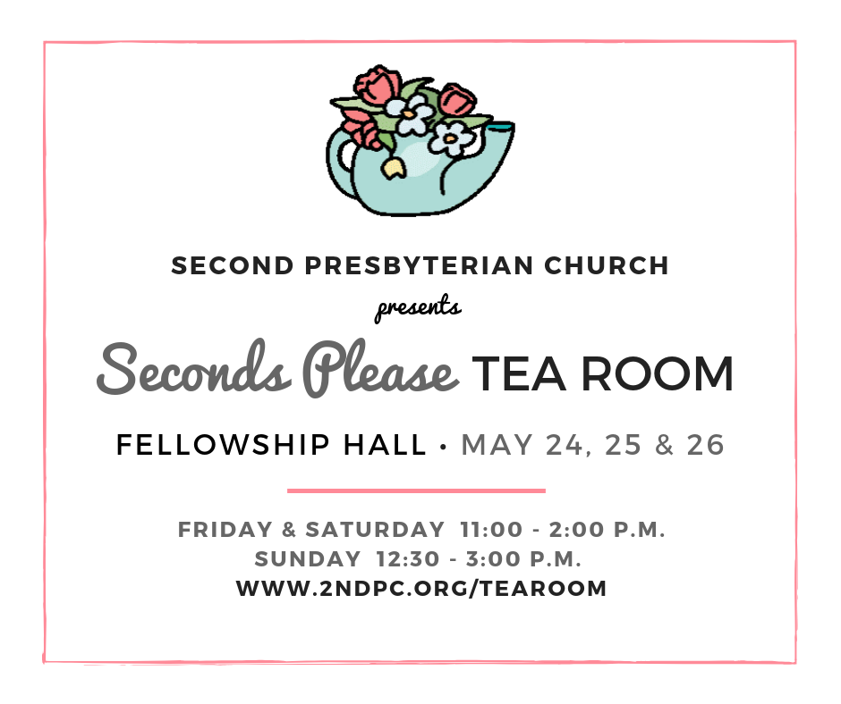
Looking ahead…

Cress Darwin, Pastor
cdarwin@2ndpc.org
Sarah Craven, Director of Christian Education, sarah.craven@2ndpc.org
Dr. Julia Harlow, Director of Music
jharlow@2ndpc.org
Lee Lingle, Chancel Choir Director
leelingle3@gmail.com
Suzann Lilienthal, Administrator
suzann.lilienthal@2ndpc.org
Jordyn Pritchard, Communications
jordyn.pritchard@2ndpc.org
Annie Ravenel, Housekeeping
Chuck Medbery, Elder of the Month
Aniyah Legare, Liturgist
Nicole Schuerman, Greeter
Sue Henderson, Director of Kindergarten
Erin Kerr, Asst. Director of Kindergarten

COMMITTEES
Aled Pritchard, Christian Education
Debra J. Gammons, Finance
Sarah Mitchell, Missions
Tina Smith, Music & Worship
Rob McCready, Property
Dave Jackson, Stewardship

Ann Hackett
Liz McNulty
Alice Willoughby
Marion Mitchell
Elizabeth O'Quinn
Zach Wright
Karen Freeman
Susanne McLaughlin
Dawn Mears
Mark Saunders
Tripp Accardo
Carolyn Jenkins
Walt Jeter
Benjamin Street
Trip Carrington
Clay Brock
Bill McLean
Burke Lackey
Isabelle Burroughs
Margaret Fleming
Allyson Hiers
Cody Baumer
Patrick McNulty
Bud Hay
Cassie Jaffe
Carter Fox
Ivey Jeter
Katherine Albright
Matt Richert

1
1
1
2
3
3
4
5
5
5
6
6
9
9
10
11
14
16
21
21
22
23
23
24
24
25
28
31
31

Jl.,l;l

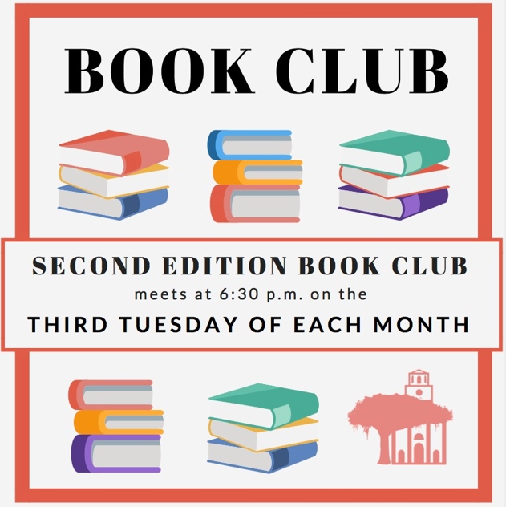

Second Presbyterian church 342 meeting street, Charleston, sc 29403 843.723.9237 www.2ndpc.org

