This is God's House - All are Welcome
“Meeting people at their point of need, Inviting all into a dynamic relationship with Christ”

Sunday, March 18, 2018 9:30 a.m.

FIFTH SUNDAY OF LENT

*Congregation please stand and sing:

Holy, Holy, Holy! Lord God Almighty! Early in the morning our song shall rise to Thee;

Holy, Holy, Holy! Merciful and mighty! God in three Persons, blessed Trinity!

GATHERING AROUND THE WORD

*Call to Worship
Leader: Come, let us worship our God of steadfast love and hope.
People: God, breathe life into us and let us live.
Leader: Set our minds on Your holy spirit of life and peace.
People: We gather here in the hope of God’s holy word and the gift of new life.

*Hymn To God Be the Glory GG #634

Invocation

Lord's Prayer Unison
Our Father, who art in heaven, hallowed be Thy name. Thy kingdom come Thy will be done on earth as it is in heaven. Give us this day our daily bread and forgive us our trespasses as we forgive those who trespass against us. Lead us not into temptation, but deliver us from evil. For Thine is the kingdom, and the power, and the glory, forever. Amen.

CONFESSION OF SIN & ASSURANCE OF PARDON

Call to Confession Unison
Spirit of the Living God, breathe fresh life on us this day. Forgive us the sins of impatience, anger, gossip and arrogance. We confess that these sins steal life from others around us and create chaos rather than peace. Forgive us our doubts and fears, the times when we cut you off and lose hope. Breathe upon us and lift us up with the Spirit of life. Forgive us the times when we feel you have let us down. Open us up to new life. Give us courage to believe in you, and boldness in living your will for us.

(A time of Silent Prayer)

Amen / Assurance of Pardon

*Gloria Patri

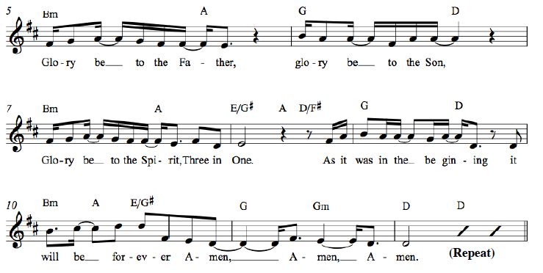

*Affirmation of Faith Apostles’ Creed
I believe in God the Father Almighty, Maker of heaven and earth, and in Jesus Christ his only Son our Lord; who was conceived by the Holy Ghost, born of the Virgin Mary, suffered under Pontius Pilate, was crucified, dead, and buried; he descended into hell*; the third day he rose again from the dead; he ascended into heaven, and sitteth on the right hand of God the Father Almighty; from thence he shall come to judge the quick and the dead. I believe in the Holy Ghost; the holy catholic** Church; the communion of saints; the forgiveness of sins; the resurrection of the body; and the life everlasting. Amen.
* ”hell” refers to the Hebrew word “Sheol,” a place of the dead, rather than the Hell of the final judgment.
** “catholic” is Latin for “universal,” implying the Christian unity that exists beyond all denominations.

*Hymn His Eye Is on the Sparrow GG #661

Welcome and Announcements
Leader: This is the day the Lord hath made. Response: Let us rejoice and be glad in it!
(at the beginning of the announcements the children are invited to go to Sunday School)

Presentation of our Gifts
*Doxology (Please sing together, as we give our tithes and offerings.)

Praise God from whom all blessings flow, Praise him all creatures here below.
Praise Him above ye heavenly hosts, Praise Father, Son and Holy Ghost.
To God all honor, to God all praise, to God all glory, forever more, Amen. (2x)

Pastoral Prayer of the People

PROCLAIMING THE WORD

First Scripture Reading Ephesians 6:10-18 Page 195

Musical Reflection

Second Scripture Reading Romans 8:35-39 Page 158

Sermon You Can Use My Helmet, Love God Rev. Gale Cooper

*Hymn God Be with You Till We Meet Again GG #541

Prayer for Illumination and Understanding

Questions about the Sermon Raise your hand or text to (843) 608-8447

*Benediction

*Please stand as you are able

INFORMATION/ANNOUNCEMENTS
Are you looking for a church home where you can make a difference for the God we serve, and a place where you will be known, nurtured, challenged? We welcome you and invite you to spend some time with us.

seCond family PrayerS – Virginia Harding, Ruth Carr, Denise Girard, Courtney Waring and Myra Mceachern, mother of Debra Luhn, and her siblings.

REV. GALE COOPER is our guest preacher today. She was born in Windsor, England before immigrating with her family and growing up in Richmond, VA. She and her husband, Elliott, have two adult, married daughters- including our own Cathy Lipp- and three grandsons. She is looking forward to her 50th wedding anniversary coming up this year. Gale is currently a volunteer chaplain with Coastal Crisis Chaplaincy and Bishop Gadsden Retirement community. Being a wife, mother, friend, priest, artist, and writer have been the main blessings of her life. She likes to paint, sew, read, travel, and spend time with friends.

EASTER LILIES – If you would like to make a donation this Easter season for lilies they are $12/each. Complete an order form and include with your donation in the offering plate or online at 2ndpc.org/give.

NEW MEMBERS – The new members class will be held today at 12:30pm in the conference room upstairs in the Education Building. New members will be received next Sunday, March 25th.

PAlm sunday – Children who would like to participate in a palm processional need to come 10 minutes prior to each service next Sunday.

Sing with the choir – The Postlude in the service on Easter Sunday will be the "Hallelujah Chorus" from Handel's Messiah. All those interested in singing along with the choir are invited to come upstairs to the choir loft during the final hymn so we can sing this glorious work together. Music will be available.

SPECIAL OFFERING – Our special offering for the One Great Hour of Sharing will be given on April 1st. 36% of the offering goes to the Presbyterian Hunger Program (PHP). PHP works to alleviate hunger and eliminate its root causes. As part of this mission, in 2016 PHP gave over 160 grants totaling more than $1.2 million, impacting communities across the United States and 37 other countries. Find more info at presbyterianmission.org/hunger.

EGG HUNT – The annual Easter Egg Hunt with First(Scots) will be held Saturday, March 31st. Join us for fun, fellowship & games. Doors open at 9:30am and the hunt will start promptly at 10am. We are in need of individually wrapped candy (peanut-free) & small prize donations. All donations can be dropped off at the church office. We will also need volunteers the day of the event. Please email Liv if you can help.

SECOND EDITION BOOK CLUB – Our new novel, Origin by Dan Brown, deals with issues germane to the modern Church as well as some fun AI (artificial intelligence) shenanigans. Tuesday, March 20th we will meet at Carol White's home: 1645 Cristalino Circle 29414 at 6:30pm. Join us for fun, fine food and conversation.

SPIRITED BRUNCH – We will be participating in the Spirited Brunch event April 22nd from 12:30-3:30pm. The Spirited Brunch is a self-guided snack tour of downtown Charleston congregations.

SIGN UP FOR VBS – Vacation Bible School will be June 24th-28th from 5:30-8:00pm. Volunteer and participants can sign up now. There are many ways to serve for this instrumental week; you can volunteer to teach, lead, provide supplies, or help with the meals. Registration forms and more information available at 2ndpc.org.

Tea Room – Join us Fridays and Saturdays, May 25th & 26th and June 1st & 2nd, from 11-2pm for lunch, cake & tea to benefit our missions program. Volunteer sign up will begin mid-April.

liturgists, greeters, and ushers are needed on Sunday mornings. No special experience necessary! Email Tina, skippytsmith@gmail.com, if you would like to know more. Sign up quickly and easily at bit.ly/2ndsignup.

Looking ahead…

SUNDAY, March 18
9:30 a.m. – Chapel Service
10:00 a.m. – Sunday School
11:15 a.m. – Sanctuary Service
MONDAY, March 19
TUESDAY, March 20
6:00 a.m. – Body Pump
7:00 p.m. – Spiritual Ensemble Rehearsal
7:00 p.m. – Young Professionals (Downtown)
7:30 p.m. – Young Professionals (West Ashley)
WEDNESDAY, March 21
6:00 a.m. – Kickboxing
5:00 p.m. – Bell Choir Rehearsal
5:30 p.m. – Supper at Second
6:30 p.m. – Choir Rehearsal
THURSDAY, March 22
6:00 a.m. – Body Pump
FRIDAY, March 23
SATURDAY, March 24
11:00 a.m. – Sisters in Serenity Group
SUNDAY, March 25
Palm Sunday
9:30 a.m. – Chapel Service
10:00 a.m. – Sunday School
11:15 a.m. – Sanctuary Service
Welcome New Members

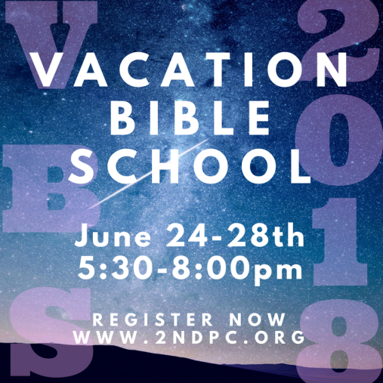

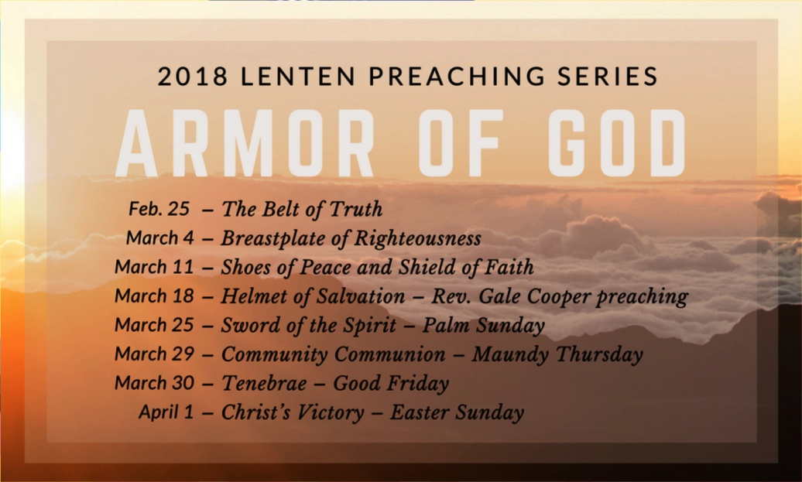

Cress Darwin, Pastor
cdarwin@2ndpc.org
Dr. Julia Harlow, Director of Music
jharlow@2ndpc.org
Tim Thompson, Chapel Music Director
Lee Lingle, Chancel Choir Director
Olivia Cappelmann, Director of Youth & Christian Education olivia.cappelmann@2ndpc.org
Colin Kerr, Director of Campus &
Young Adult Ministry charlestonjourney@gmail.com
Suzann Lilienthal, Administrator
suzann.lilienthal@2ndpc.org
Jordyn Pritchard, Communications
jordyn.pritchard@2ndpc.org
Annie Ravenel, Housekeeping
Dave Jackson, Elder of the Month
AJ Manett, Liturgist
Meredith & Jeff Bird, Greeters
Sue Henderson, Director of Kindergarten
Erin Kerr, Asst Director of Kindergarten

1st
2nd
3rd
5th
5th
6th
7th
7th
8th
9th
9th
10th
10th 11th
11th
12th
15th
20th
22nd
22nd
24th
24th
24th
28th
29th
29th
30th
Wyatt Lipp
Kenny Ayers
Elizabeth Gouldon
Devvy Cappelmann
Alice Reitzel
Russell Powell
Pat Mellen
Christopher Ott
Mary Hackett
Kelly Bailey
Liz Boles
Scott Burroughs
Jerald Hucks
Julia Howe
Cal Oyer
Morgan McClure
Susan Lovell
Mary Edna Fraser
Sarah Morton
Mary Hellen Siegling
Dewitt King
Katie McClure
June McKnight
Robbie Staubes
Virginia Harding
Robert Hoffman
Peggy Ricker

Second Presbyterian church 342 meeting street, Charleston, sc 29403 843.723.9237 www.2ndpc.org

