This is God's House - All are Welcome
“Meeting people at their point of need, Inviting all into a dynamic relationship with Christ”

Sunday, February 26, 2017 9:30 a.m.

Prelude Holly Slice, pianist

*Congregation please stand and sing:

Holy, Holy, Holy! Lord God Almighty! Early in the morning our song shall rise to Thee;

Holy, Holy, Holy! Merciful and mighty! God in three Persons, blessed Trinity!

GATHERING AROUND THE WORD
*Call to Worship
Leader: The Lord is Sovereign; let the people tremble.
People: The Lord is enthroned forever; let the earth shake.
Leader: Proclaim God’s greatness and worship on God’s holy mountain.
People: For the Lord our God is the Holy One among us.
*Hymn It Is Well with My Soul - GG 84
Invocation

Lord's Prayer Unison
Our Father, who art in heaven, hallowed be Thy name. Thy kingdom come Thy will be done on earth as it is in heaven. Give us this day our daily bread and forgive us our trespasses as we forgive those who trespass against us. Lead us not into temptation, but deliver us from evil. For Thine is the kingdom, and the power, and the glory, forever. Amen.

CONFESSION OF SIN & ASSURANCE OF PARDON
Call to Confession Unison
Holy God, hearing today of Jesus’ transfiguration, we become aware that we ourselves
need to be changed. Sin stains our lives, and soils our hearts. We are seemingly incapable
of doing good and the truth is often far from us. Cleanse us with your love. Wipe away our
transgressions. Purify us so that we might begin again to follow in your way.

(A time of Silent Prayer)

Amen

Assurance of Pardon

*Gloria Patri Glory to God, Whose Goodness Shines on Me

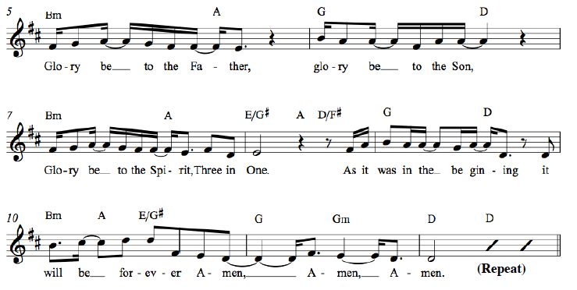

*Affirmation of Faith Apostles’ Creed
I believe in God the Father Almighty, Maker of heaven and earth, and in Jesus Christ his only Son our Lord; who was conceived by the Holy Ghost, born of the Virgin Mary, suffered under Pontius Pilate, was crucified, dead, and buried; he descended into hell*; the third day he rose again from the dead; he ascended into heaven, and sitteth on the right hand of God the Father Almighty; from thence he shall come to judge the quick and the dead. I believe in the Holy Ghost; the holy catholic** Church; the communion of saints; the forgiveness of sins; the resurrection of the body; and the life everlasting. Amen.

* ”hell” refers to the Hebrew word “Sheol,” a place of the dead, rather than the Hell of the final judgment.
** “catholic” is Latin for “universal,” implying the Christian unity that exists beyond all denominations.

*Hymn Speak O Lord HMA 110
Welcome and Announcements
Leader: This is the day the Lord hath made. Response: Let us rejoice and be glad in it!
(at the beginning of the announcements the children are invited to go to Sunday School)

Presentation of our Gifts *Doxology (Please sing together, as we give our tithes and offerings.)

Praise God from whom all blessings flow, Praise him all creatures here below.
Praise Him above ye heavenly hosts, Praise Father, Son and Holy Ghost.
To God all honor, to God all praise, to God all glory, forever more, Amen. (2x)

Pastoral Prayer of the People

PROCLAIMING THE WORD

First Scripture Reading 2 Peter 1:16-21 Page 232

Musical Reflection

Second Scripture Reading Matthew 17:1-9 Page 18 Page 18 Page

Sermon Transfigured Rev. Cress Darwin

Prayer for Illumination and Understanding

Questions about the Sermon Raise your hand or text to ( 843) 608-8447

*Hymn Before the Throne of God Above HMA 14
*Benediction

INFORMATION/ANNOUNCEMENTS
Are you looking for a church home where you can make a difference for the God we serve, and a place where you will be known, nurtured, challenged? We sincerely welcome you and invite you to spend some time with us.

CHILDREN and YOUTH MUSIC: Children ages 3-10 are welcome in Children’s Choir, which meets with Holly Slice in the Chapel from 10:30-11:00 on Sunday mornings. Youth ages 11-15 are welcome in Junior Choir, which meets with Dr. Julia Harlow in the Choir Room from 10:30-10:45 Sunday mornings. For more info: jharlow@2ndpc.org

HYMNALS and CDs: If you would like a copy of our old hymnal or a CD of our choir, please pick one up in the narthex. If you know of a church or school that would like copies of our old hymnal, please let Julia Harlow know: jharlow@2ndpc.org

seCond family PrayerS – Annie Ravenel, Aaron Smith, grandson of Tammy Vermilling, Pat Garrett, Margaret Baumer, Susan Harbin, Catherine Ann Suarez, Edward Mason, Maria Fitzharris, Milt Maness, Beverly McClure, McCoy Family, Betty Freeman.

SPK ANNUAL CANNED FOOD DRIVE - To support the Low Country Food Bank the kindergarten will be collecting canned for during February 15-26th! Help us reach our goal of 200 cans by February 26th! Donations can be placed in the barrel in the SPK foyer.

JULIA HARLOW will play the harpsichord in a short, free concert Tuesday, Feb. 21, 12:15-12:45 p.m. at St. Luke's Chapel (corner of Ashley and Bee streets) at MUSC.

SIGN UP FOR THE NEW MEMBERS CLASS
Feel called to join the Second Pres family? Have questions about Christianity or what it means to be a Presbyterian? Or maybe you just want a refresher on your faith? Sign up for our What We Believe/New Members class in March. Meet for two Sunday mornings, (in the upstairs conference room) after worship to explore how world religions compare to the Gospel of Jesus Christ, Reformed history and theology, denominational distinctives, and what it means to be a member at Second Presbyterian Church. Contact Colin Kerr at charlestonjourney@gmail.com for more information or to register.

Sunday, March 12th, after 11:15 worship - First Class
Sunday, March 26th, after 11:15 worship - Second Class
Sunday, April 9th, 10 am - Wrap up & New Members Sunday
Lunch, childcare if necessary, & fellowship. Each session is an hour and a half.

THE SECOND PRESBYTERIAN CHURCH
NOMINATING COMMITTEE NEEDS YOUR INPUT
We have multiple Church officer positions to be filled and your input is vital. Copies are available at the back of the church or you may download the form from the Church website, and submit your recommendations by March 12, 2017. Return your completed forms to the Church office, a member of the nominating committee or to andrew.manett@gmail.com. Thank you for your support.

Looking Ahead.......
SUNDAY, February 26
9:30 a.m. - Worship in the Chapel
10:30 a.m. – Children’s Music Program
11:15 a.m. -Worship in the Sanctuary
Kindergarten Sunday
MONDAY, February 27
6:00 a.m. – Body Pump
TUESDAY, February 28
5:30 p.m. - Gospel Choir Rehearsal
5:30 p.m. - Pancake Supper
7:00 p.m. – Spiritual Ensemble Rehearsal
7:30 p.m. - Young Professionals (WA)
WEDNESDAY, March 1
Ash Wednesday
6:00 a.m. - Body Pump
9:00 a.m. - Worship & Voluntary Imposition of Ashes
9:30 a.m. - Chapel for Preschool
5:00 p.m. - Bell Choir Rehearsal
6:15 p.m. - College Study
6:30 p.m. - Women's Bible study
6:30 p.m. - Reaffirmation of Baptismal Vows
THURSDAY, March 2
7:00 p.m. – Young Professionals (Downtown)
FRIDAY, March 3
6:00 a.m. – Body Pump
SATURDAY, March 4
11:00 a.m. - Sisters in Serenity Group
12:00 p.m. - Church Oyster Roast
SUNDAY, March 5
9:30 a.m. - Worship in the Chapel
10:30 a.m. – Children’s Music Program
11:15 a.m. – Worship in the Sanctuary
Communion
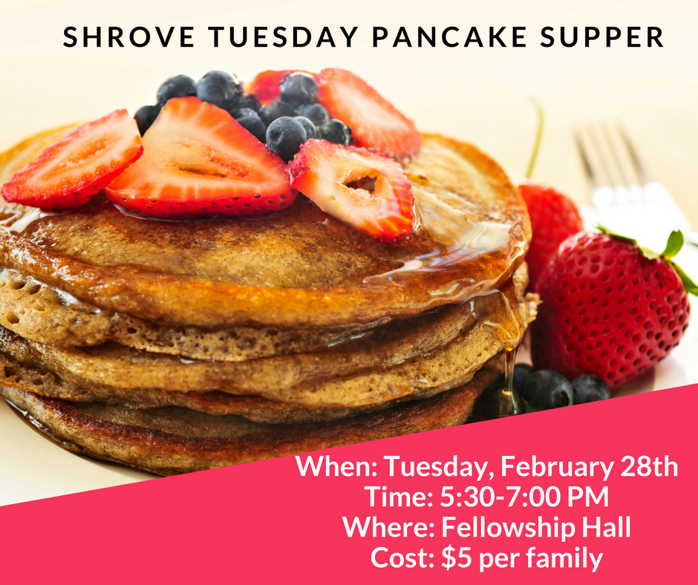
A little history about Shrove Tuesday and pancakes…
The name Shrove comes from the old word “shrive” which means to confess. In the Middle Ages, people would confess their sins on Shrove Tuesday to begin the penitent Lenten season with a clean slate! Shrove Tuesday is a day of celebration as well as repentance. Lent is historically a time of giving things up, so Shrove Tuesday is the last chance to indulge. Pancakes are eaten on this day because they contain fat, butter and eggs (significant, flavorful food groups which were forbidden during Lent).

MARCH
12 Morgan McClure
15 Susan Lovell
20 Mary Edna Fraser
22 Sarah Morton
22 Mary Siegling
24 DeWitt King, Jr.
24 Katie McClure
24 June McKnight
28 Robbie Staubes
29 Virginia Harding
29 Robert Hoffman
30 Peggy Ricker
1 Wyatt Lipp
2 Ken Ayers
3 Elizabeth Gouldon
5 Devvy Capplemann
7 Pat Mellen
7 Christopher Ott
8 Mary Hackett
9 Kelly Bailey
9 Elizabeth Boles
10 Scott Burroughs
10 Jerald Hucks
11 Julia Howe
11 Cal Oyer

17 Melody Taylor
18 Virginia Hesse
18 TJ Ockerman
19 Kristen LaSeta
19 Patricia McKelvin
20 Cynthia McLean
20 Richard Weatherly Jr.
22 Heath Beam
23 Dorothy Leslie
24 Michael Long
24 Mary McKinley
25 Katie Kirchoff
25 Gilbert Milner
26 Stephen Chandler
27 Ameila Gustafson
27 Janine Sellers
28 Shelley Howe
29 Bobby Howe
29 Alexis Kerr

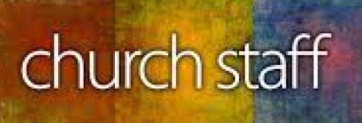

Cress Darwin, Pastor
cdarwin@secondpresbyterianchurch.org
Dr. Julia Harlow, Director of Music
jharlow@2ndpc.org
Olivia Cappelmann, Director of youth & Christian Education olivia.cappelmann@2ndpc.org
Colin Kerr, Director of Campus &
Young Adult Ministry
charlestonjourney@gmail.com
Suzann Lilienthal, Administrator
suzann.lilienthal@2ndpc.org
Holly Slice, Director of Chapel Music
Annie Ravenel, Housekeeping
Melvin Kizer, Church Sexton
Tina Smith, Head Usher
Gene McMurray, Liturgist, 9:30 a.m.
Laura Ott, Liturgist, 11:15 a.m.
Randy Cook, Elder of the Month
Dolly & Terry Hamlin, Greeters
Sue Henderson, Director of Kindergarten
Erin Kerr, Asst Director of Kindergarten

Second PresBYTERIAN Church
Annual Oyster Roast
WHEN: Saturday, March 4, 2017
TIME: 12:00 - 3:00 pm
WHERE: “In the Park"
Bring a side dish or dessert
RSVP please, 723-9237

MONTREAT – Will be hosting their 2017 Youth & Middle Scool Conferences in June & July. Both conferences are a unique gathering of young people from all over the country for a week of study, worship, and recreation. Activities include morning energizers, music, keynote, small group meetings, afternoon recreation activities, and evening worship. Come experience God’s transformative love in creative and amazing ways with friends new and old. To sign up, or for more information, please email Liv (olivia.cappelmann@2ndpc.org) by March 13th.

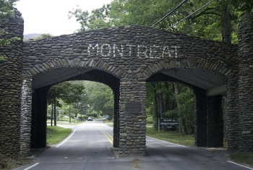

WEDNESDAY SUPPER SCHEDULE
March 8 – Session 2
March 15 - Session 3
March 29 - Mixed Adults SS Apr 5 - Young Families
Apr 12 - Men's Society
Apr 19 - Women's Bible Study
Apr 26 - Thursday Night SmGp

