This is God's House - All are Welcome
“Meeting people at their point of need, Inviting all into a dynamic relationship with Christ”

Sunday, December 10, 2017 9:30 a.m.

Second SUNDAY OF ADVENT

*Congregation please stand and sing:

Holy, Holy, Holy! Lord God Almighty! Early in the morning our song shall rise to Thee;

Holy, Holy, Holy! Merciful and mighty! God in three Persons, blessed Trinity!

GATHERING AROUND THE WORD

*Call to Worship
Leader: O Wisdom, coming forth from the mouth of the Most High, you order all things with strength and gentleness: come now and teach us the way of salvation.
People: Come, Lord Jesus!
Leader: O Adonai, Ruler of your people Israel, you appeared to Moses and gave us your law at Sinai: Come with outstretched arm to save us.
People: Come, Lord Jesus!
Leader: O Root of Jesse, rising as a sign for all peoples, before you all earthly rulers will keep silent and nations will give you honor: Come quickly to deliver us.
People: Come, Lord Jesus!
Leader: O Radiant Dawn, splendor of eternal light, Sun of justice: Come, shine on those who live in darkness and in the shadow of death.
People: Come, Lord Jesus!
Leader: O Immanuel, our Sovereign and Lawgiver, desire of the nations and our Savior: Come and save us, O Lord our God.
People: Come, Lord Jesus!

LIGHTING OF THE ADVENT WREATH Kerr family
Last week we lit the candle of HOPE.
Now, on the second Sunday of Advent we light the candle for PEACE.

Hear Zechariah’s song of hope for peace to the Christ child; a reading from Luke 1:76-79:
You, child, will be called the prophet of the Most High; for you will go before the Lord to prepare his ways,
to give knowledge of salvation to his people by the forgiveness of their sins,
By the tender mercy of our God, the dawn from on high will break upon us,
to give light to those who sit in darkness and in the shadow of death,
to guide our feet into the way of peace.

Let us pray together:
God of hope, Prince of Peace, you speak peace into the world in the Way of the Christ child.
Help us embody your peace and live as peacemakers that we may be called children of God.
God of hope, God of peace, into our darkness come.

*Hymn Hark! The Herald Angels Sing #127

Invocation

Lord's Prayer Unison
Our Father, who art in heaven, hallowed be Thy name. Thy kingdom come Thy will be done on earth as it is in heaven. Give us this day our daily bread and forgive us our trespasses as we forgive those who trespass against us. Lead us not into temptation, but deliver us from evil. For Thine is the kingdom, and the power, and the glory, forever. Amen.

CONFESSION OF SIN & ASSURANCE OF PARDON

Call to Confession Unison
God of mercy, we want to be ready to welcome you into our hearts and lives. We get caught up in activities that take us farther away from the silence and the stillness of the night of your birth. We get captured by anxieties and busyness. Too often we neglect or ignore that to prepare for your coming, we must repent. We often miss the mark in our scattershot obedience; we seldom forgive others as we need to be forgiven. By the fire of your righteousness, cleanse us from our known and our hidden sins, we pray.

(A time of Silent Prayer)

Amen / Assurance of Pardon

*Gloria Patri
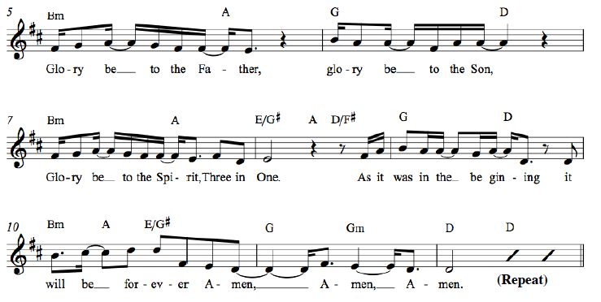

*Affirmation of Faith Apostles’ Creed
I believe in God the Father Almighty, Maker of heaven and earth, and in Jesus Christ his only Son our Lord; who was conceived by the Holy Ghost, born of the Virgin Mary, suffered under Pontius Pilate, was crucified, dead, and buried; he descended into hell*; the third day he rose again from the dead; he ascended into heaven, and sitteth on the right hand of God the Father Almighty; from thence he shall come to judge the quick and the dead. I believe in the Holy Ghost; the holy catholic** Church; the communion of saints; the forgiveness of sins; the resurrection of the body; and the life everlasting. Amen.
* ”hell” refers to the Hebrew word “Sheol,” a place of the dead, rather than the Hell of the final judgment.
** “catholic” is Latin for “universal,” implying the Christian unity that exists beyond all denominations.

*Hymn Savior, Like a Shepherd Lead Us #187 #88

Welcome and Announcements
Leader: This is the day the Lord hath made. Response: Let us rejoice and be glad in it!
(at the beginning of the announcements the children are invited to go to Sunday School)

Presentation of our Gifts
*Doxology (Please sing together, as we give our tithes and offerings.)

Praise God from whom all blessings flow, Praise him all creatures here below.
Praise Him above ye heavenly hosts, Praise Father, Son and Holy Ghost.
To God all honor, to God all praise, to God all glory, forever more, Amen. (2x)

Pastoral Prayer of the People
PROCLAIMING THE WORD

First Scripture Reading Mark 1:1-8 Page 34

Musical Reflection

Second Scripture Reading Isaiah 40:1-11 Page 667

Sermon Reporting From the Wilderness Rev. Cress Darwin

Prayer for Illumination and Understanding

Questions about the Sermon Raise your hand or text to (843) 608-8447

*Hymn Go, Tell It on the Mountain #136

*Benediction
*Please stand as you are able

INFORMATION/ANNOUNCEMENTS
Are you looking for a church home where you can make a difference for the God we serve, and a place where you will be known, nurtured, challenged? We welcome you and invite you to spend some time with us.

seCond family PrayerS – Pat McKevlin, Debra and Robert Luhn, Schyenne Tyler, Susanne Mclaughlin, Aaron Smith, Tammy Vermilling’s grandson

COMING UP – On Dec. 17th for our annual Advent Presentation, movements from Handel's "Messiah", featuring soloists, choir and strings, will be presented in the 11:15 service.

ADULT Sunday School Christmas Party – Come enjoy the beauty of Christmas and a time of fellowship and good food at the Mixed Adults Sunday School Christmas Party on December 14th from 6-8pm. Hosted by Debbie & Patterson Smith at 929 Parrot Creek Way on James Island. Please bring a dish to share.

Poinsettias – Poinsettias ($15 each) are now available for order. You can find an order form in your pew, inside the Education Building or online at www.2ndpc.org.

CHRISTMAS PAGEANT – The children’s Christmas Pageant will be Sunday, December 17th at 5pm with supper to follow. The last practice is after supper on Wednesday, December 13th from 6:15-7:30pm.

sunday school at 10am – Each week the Mixed Adult Sunday School Class meets to study a passage from the Bible as offered in The Present Word curriculum. All adults welcome! Children meet at 10am as well: Kindergarteners and younger in the Green Room and 1st-5th Graders upstairs in the Youth Room. Youth meet for Donuts & Devotion next on December 17th in room 209.

AMAZON SMILE – Support Second Pres when you shop this holiday season! Shop for everyone on your list this Christmas through this link: bit.ly/2ndpcsmile, or choose to support ‘Second Presbyterian Church” at smile.amazon.com and Amazon will donate to Second Presbyterian with each purchase you make.

Travel club – A Travel Club is forming and will meet once a month so people can gather to talk about travel experiences, future plans, and hopefully even take some weekend trips together. A "Get to Know You" Meeting is coming up in January. Contact Nicole Schuerman (nschuerman@yahoo.com or 630-853-4734) for more info.

Large PRINT HYMNALS – Large print hymnals are available on the table in the back of the Sanctuary.
LOOKING AHEAD...

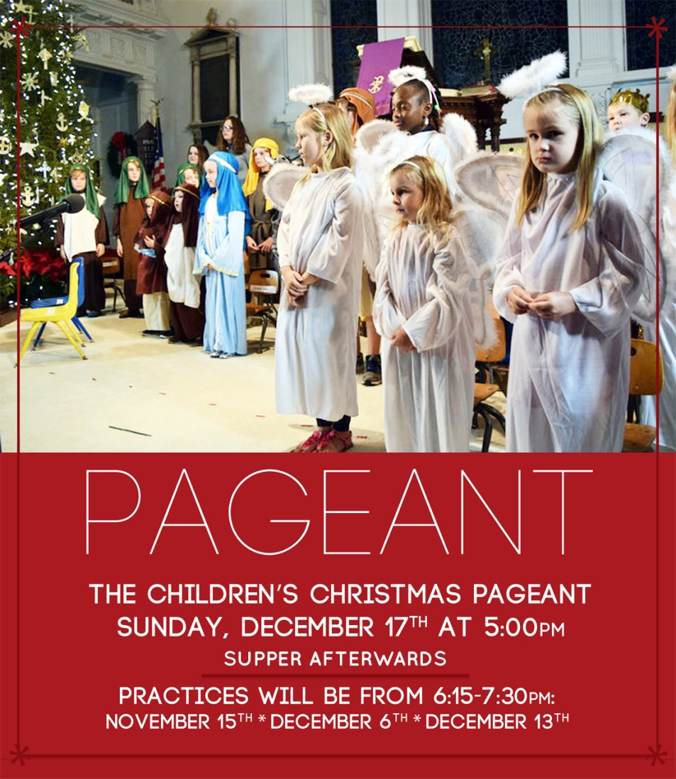
SUNDAY, December 10
9:30 a.m. – Chapel Service
10:00 a.m. – Sunday School
11:15 a.m. – Worship in the Sanctuary
MONDAY, December 11
TUESDAY, December 12
6:00 a.m. – Body Pump
5:30 p.m. – Session Meeting
7:00 p.m. – Spiritual Ensemble Rehearsal
7:00 p.m. – Young Professionals (Downtown)
7:30 p.m. – Young Professionals (West Ashley)
WEDNESDAY, December 13
6:00 a.m. – Kickboxing
5:00 p.m. – Bell Choir Rehearsal
5:30 p.m. – Supper at Second
6:15 p.m. – Children’s Pageant Rehearsal
6:30 p.m. – Choir Rehearsal
THURSDAY, December 14
6:00 a.m. – Body Pump
FRIDAY, December 15
SATURDAY, December 16
11:00 a.m. – Sisters in Serenity Group
SUNDAY, December 17
9:30 a.m. – Chapel Service
10:00 a.m. – Sunday School
11:15 a.m. – Worship in the Sanctuary
5:00 p.m. – Christmas Pageant and Supper

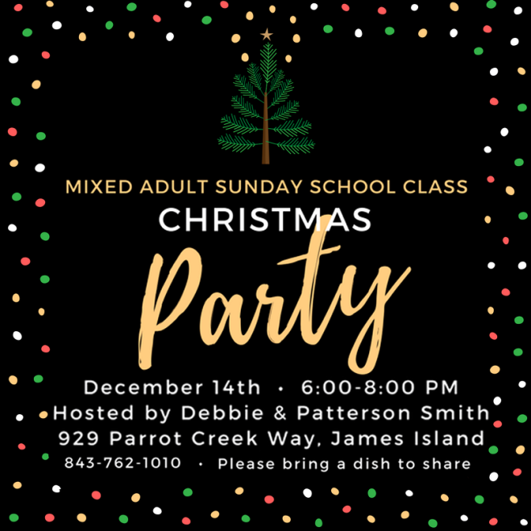

Cress Darwin, Pastor
cdarwin@secondpresbyterianchurch.org
Dr. Julia Harlow, Director of Music
jharlow@2ndpc.org
Olivia Cappelmann, Director of Youth & Christian Education olivia.cappelmann@2ndpc.org
Colin Kerr, Director of Campus &
Young Adult Ministry
charlestonjourney@gmail.com
Suzann Lilienthal, Administrator
suzann.lilienthal@2ndpc.org
Jordyn Pritchard, Communications
jordyn.pritchard@2ndpc.org
Annie Ravenel, Housekeeping
Melvin Kizer, Church Sexton
Tim Thompson, Chapel Music Director
Brad Milner, Elder of the Month
Felicia Sanders, Head Usher
AJ Manett, Liturgist
Maylin & Chris Taylor, Greeter
Sue Henderson, Director of Kindergarten
Erin Kerr, Asst Director of Kindergarten

2nd
3rd
3rd
7th
8th
10th
10th
13th
15th
18th
18th
19th
19th
19th
20th
20th
25th
26th
28th
28th
29th
31st
31st

Trish Milner
Harper Briggs-Most
Kristin James
Michael Ott
Sarah Coleman
Bradshaw Milner
Nick Thompson
Cathy Lipp
Erin Kerr
Rosie Bailey
Ervene Hiers
Reece Hucks
Kimberly McMurray
Virginia Street
Nancy Brooks
Calista Freeman
Sally Ramsdell
Ashley Thompson
Llewellyn Clarke
Rob Luhn
Gracie Smythe
Alex Bartlett
Amy Roddey

