This is God's House - All are Welcome
“Meeting people at their point of need, Inviting all into a dynamic relationship with Christ”

November 18, 2018 `11:15 a.m.

Pre-Service Music Prelude on “Kremser” Robin Rokey

*Processional Hymn
Holy, Holy, Holy! Lord God Almighty! Early in the morning our song shall rise to Thee;
Holy, Holy, Holy! Merciful and mighty! God in three Persons, blessed Trinity.

WELCOME AND ANNOUNCEMENTS
Leader: This is the day the Lord hath made. Response: Let us rejoice and be glad in it!
Minute for Missions Lee Lingle, Choir Director

Prelude "March" G.F. Handel
Bell Choir arr. Herbek

GATHERING AROUND THE WORD
*Call to Worship Micah 6,7
Leader: With what shall I come before the LORD, and bow myself before God on high? He has told you what is good:
People: What the LORD requires of you is to do justice, to love kindness, and to walk humbly with your God.
Leader: I will look to the LORD; I will wait for the God of my salvation; my God will hear me.
People: Who is a God like you, pardoning iniquity and passing over transgression, who delights in steadfast love?
Leader: He will again have compassion on us; he will tread our iniquities underfoot. You will cast all our sins into the depths of the sea.
People: You will show faithfulness to Jacob, and steadfast love to Abraham, as you have sworn to them from the days of old.

*Hymn Surely It Is God Who Saves Me #71

Invocation

Lord's Prayer (Unison)
Our Father, who art in heaven, hallowed be Thy name. Thy kingdom come, Thy will be done on earth as it is in heaven. Give us this day our daily bread and forgive us our trespasses as we forgive those who trespass against us. Lead us not into temptation, but deliver us from evil for thine is the kingdom and the power and the glory forever. Amen.

CONFESSION OF SIN & ASSURANCE OF PARDON
Call to Confession (Unison)
Holy God, you are infinite and pure, and you see all our sins. Yet, you do not love us less, or turn away from us when we repent and confess our sin. Have mercy on us. You know how often we fail, wandering from your ways. We waste your gifts and forget your love. Search our hearts, and help us to acknowledge our sins which burden our conscience. Cleanse us, O Lord, from all those things which displease you. Let your mercy bring us healing. Forgive us of all these sins and those we bring now.

Silent Confession and Assurance of Pardon
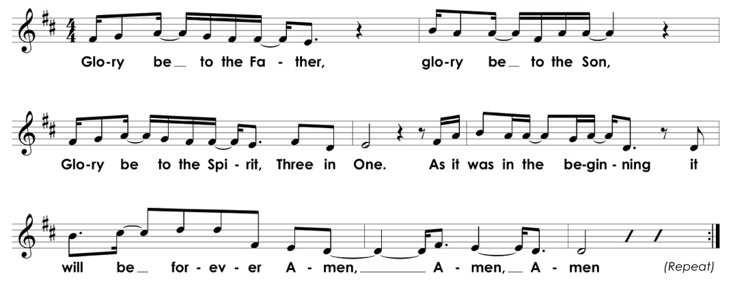
*Gloria Patri

*Affirmation of Faith Apostles' Creed
I believe in God the Father Almighty, Maker of heaven and earth, and in Jesus Christ his only Son our Lord; who was conceived by the Holy Ghost, born of the Virgin Mary, suffered under Pontius Pilate, was crucified, dead, and buried; He descended into hell; the third day He rose again from the dead; He ascended into heaven, and sitteth on the right hand of God the Father Almighty; from thence He shall come to judge the quick and the dead. I believe in the Holy Ghost; the holy catholic church; the communion of saints; the forgiveness of sins; the resurrection of the body; and the life everlasting. Amen.

PRESENTATION OF TITHES AND OFFERINGS

Offertory Anthem "Sing to the Lord of Harvest" Text: JSB Monsell, 19th c.
Music: Nuremberg, 1581, arr. Strube

Sing to the Lord of harvest, sing songs of love and praise; With joyful hearts and voices your alleluias raise.
By Him the rolling seasons in fruitful order move; Sing to the Lord of harvest, a song of happy love.

By Him the clouds drop fatness, the deserts bloom and spring. The hills leap up in gladness, the valley laugh and sing.
He filleth with His fullness all things with large increase, He crowns the year with goodness with plenty and with peace.

Bring to His sacred altar the gifts His goodness gave. The golden sheaves of harvest, the souls He died to save.
Your hearts lay down before Him when at His feet ye fall, And with your lives adore Him, who gave His life for all.

*Doxology

Praise God from whom all blessings flow; Praise him all creatures here below;

Praise Him above ye heavenly host; Praise Father, Son and Holy Ghost. Amen.

*Prayer of Dedication
We give you thanks, O Lord, for your great goodness to us and all people We give you thanks
for your unfailing faithfulness, for your mercy which is beyond measure, and for your loving hand which ever provides for us. Above all, we adore you for your love in the redemption of your people through Jesus Christ. We thank you for the presence of your Holy Spirit with your Church. In thanks, we present these offerings to you, for these and all your gifts, for your glory alone, our Lord God Almighty. Amen.

Time for Children
Litany of Parting
Children: May God be with you here. Congregation: May God be with you there.

*Hymn We Gather Together #336

Pastoral Prayer of the People

PROCLAIMING THE WORD

First Scripture Reading Psalm 16 Page 495

Second Scripture Reading 1 Samuel 1:4-20 Page 244

Sermon Hannah Takes it to the Boss Rev. Cress Darwin

*Closing Hymn My Hope Is Built on Nothing Less #353

*Benediction and Choral Response Amen Danish

Postlude “Now Thank We All Our God” JS Bach
*Please stand, as you are able. Hearing aids and large-print hymnals are available at the back of the sanctuary.

INFORMATION/ANNOUNCEMENTS
Are you looking for a church home where you can make a difference for the God we serve, and a place where you will be known, nurtured, challenged? We welcome you and invite you to spend some time with us.

seCond family PrayerS – Hope Staubes, Delores King, Jim Kimmett, Winkie Welborn, Sue Henderson, Catherine Brack, Maria Fitzharris, Kristin LaSeta, Bobby Howe, Julian Smith, friend of the Hamlin’s, and Courtney Waring.

SPECIAL OFFERING – Today we will receive the Thornwell Special Offering. As well as residential care for children, Thornwell provides family support services throughout our synod.

Community thanksgiving – All are invited as we come together for a Community Thanksgiving Service and Supper on Tuesday, November 20th. The service will start at 7 p.m. and supper will follow. This is an annual time of community as area churches come together in our sanctuary in a collaborative evening of thanksgiving and worship. Invite your friends and neighbors!

supper at second – No Supper this week. Join us on Tuesday for Community Thanksgiving instead. We will meet again next Wednesday Night for Supper and our annual Advent Craft Workshop.

ADVENT CRAFT WORKSHOP – On November 28th we will gather for Wednesday Night Supper and advent fun. Come sing Christmas hymns and there will be advent-related crafts for kids and families and the opportunity to make a “live” Advent wreath. Wreath are available for $20 on a first come, first served basis.

WORK ON A HABITAT FOR HUMANITY HOME BUILD on James Island. The build continues on November 30th & December 1st. No experience necessary! Email Trish at trishmilner@gmail.com with any questions and to sign up.

DECORATION DAY – Join the fun on December 1st as we come together to decorate the Christmas tree and church.

DROP 'N SHOP – Parents can tackle some last-minute Christmas shopping KID-FREE! On Saturday, December 8th from 9 a.m. till noon, children will enjoy Christmas crafts, movies and a special snack! Cost is $15 for the first child, $10 for each addition child, $30 family max. Email Liv to sign up by December 3rd. All money raised will go to offset costs for youth attending the Montreat Youth Conferences.

SECOND EDITION BOOK CLUB will next meet December 4th at 6:30 p.m. to discuss Three Sisters, Three Queens at the home of Carol White at 1645 Cristalino Circle in West Ashley.

the CHRISTMAS PAGEANT is Dec. 16th at 5:30. We only have three rehearsals so please make every effort to bring your child to each on time! We will rehearse again Dec. 5th & Dec. 12th after Wednesday Night Suppers from 6:15-7:30.

SECOND SUNDAY LUNCH – Join us for lunch on the second Sunday of each month after the 11:15am service, next on December 9th. Please bring a side or dessert to share. Everyone is welcome.

SUPPORT SECOND – You can support Second Pres whenever you shop on Amazon. Use the link: bit.ly/2ndpcsmile or choose to support “Second Presbyterian Church” at smile.amazon.com and Amazon will automatically donate to Second Presbyterian with each purchase you make.

SUNDAY, DEC. 16th in the 11:15 service, please come hear beautiful music by Antonio Vivaldi (1678-1741), when our choir sings selections from his "Gloria" as their annual Advent offering. The work features soloists, choir, string ensemble and organ.

TOYS FOR TOTS – Terry Hamlin’s Carolina One Real Estate office (2713 Hwy 17, Mt P) is a designated Toys for Tots drop off location. New, unwrapped toy donations are appreciated- no matter how small, how big or how many. Contact Terry for more info at 843-830-3946 or terry@thamlinproperties.com.

ALTERNATIVE GIVING – Medical Benevolence Foundation has a way for you to give gifts that make a lasting difference for people living in desperate conditions. Go to www.mbfoundation.org to give a gift that lasts.

PDA DISASTER RELIEF – You can respond to the devastation of recent disasters with your prayers and by donating directly through Presbyterian Disaster Assistance. Give, Act, Pray through pda.pcusa.org.
Looking ahead…
SUNDAY, November 18
9:30 a.m.– Chapel Service
10:00 a.m.– Sunday School
11:15 a.m.– Worship Service
MONDAY, November 19
TUESDAY, November 20
6:00 a.m.– Body Pump
5:30 p.m.– Spiritual Ensemble Rehearsal
7:00 p.m.– Community Thanksgiving
WEDNESDAY, November 21
No Supper at Second
THURSDAY, November 22
Thanksgiving Day
Church Office Closed
FRIDAY, November 23
Church Office Closed
SATURDAY, November 24
11:00 a.m.– Sisters in Serenity Group
SUNDAY, November 25
9:30 a.m.– Chapel Service
10:00 a.m.– Sunday School
11:15 a.m.– Worship Service

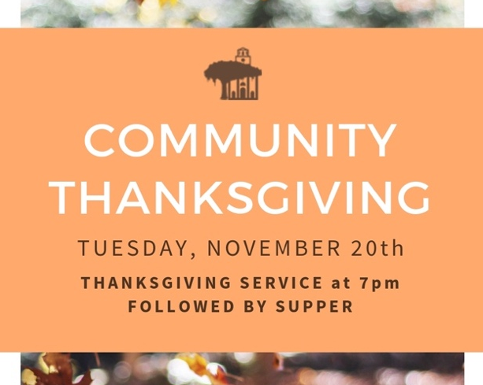

Cress Darwin, Pastor
cdarwin@2ndpc.org

Dr. Julia Harlow, Director of Music
jharlow@2ndpc.org

Lee Lingle, Chancel Choir Director
leelingle3@gmail.com

Olivia Looney, Director of Youth &
Christian Education
olivia.cappelmann@2ndpc.org

Suzann Lilienthal, Administrator
suzann.lilienthal@2ndpc.org

Jordyn Pritchard, Communications
jordyn.pritchard@2ndpc.org

Annie Ravenel, Housekeeping

Sarah (Morton) Stevens, Elder of the Month

Patterson Smith, Liturgist

Josephine Harrington, Greeter

Sue Henderson, Director of Kindergarten

Erin Kerr, Asst. Director of Kindergarten

Richard Freeman
Cathy Oyer
Josh Craw
Fran Hughes
Eleanor Smythe
Pam Luhn
Dennis Blankenship
Paul Welborn
Katherine Accardo
Terry Roddey
Christina McMurray
Ben Curran
Domonique Brown
Austin Smythe
Gloria Weile
Adam Curran
Susanne McDonald
Daniel McKnight
Rebecca Kettering
Thomas Smythe
Ann Catherine Gustafson
Christina Smith
Isla Street
Jim Kimmett
Edwin Smythe

1st
1st
3rd
4th
8th
10th
11th
11th
13th
13th
15th
16th
17th
19th
19th
20th
20th
20th
24th
24th
25th
25th
25th
27th
30th

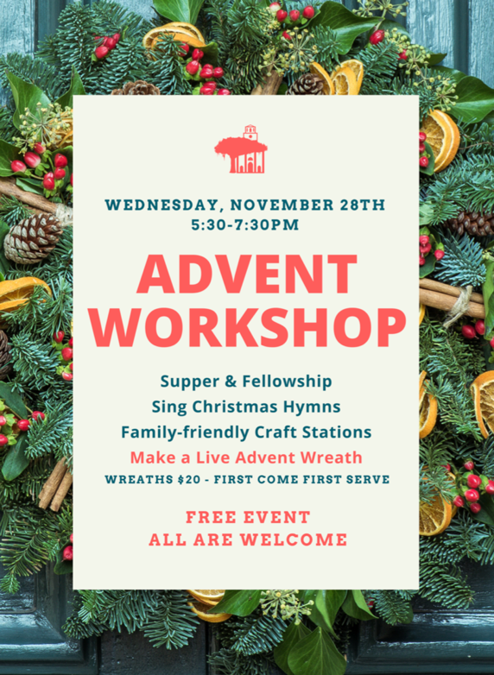

Second Presbyterian church 342 meeting street, Charleston, sc 29403 843.723.9237 www.2ndpc.org

