This is God's House - All are Welcome
“Meeting people at their point of need, Inviting all into a dynamic relationship with Christ”

October 13, 2019 10:30 a.m.

PreService Music Movements from the 'Convent Mass' Francois Couperin

*Processional Hymn:
Holy, Holy, Holy! Lord God Almighty! Early in the morning our song shall rise to Thee.
Holy, Holy, Holy! Merciful and mighty! God in three Persons, blessed Trinity!

WELCOME
Leader: This is the day the Lord hath made. Response: Let us rejoice and be glad in it!

Prelude Verset Leon Boellmann

GATHERING AROUND THE WORD
*Call to Worship
Leader: How lovely is your dwelling place, O Lord of Hosts!
People: Our souls long for your courts, where we yearn to sing your praises.
Leader: Blessed are they who dwell in your house, who are always praising you.
People: Blessed are those whose strength is in you, whose hearts are set on the
pilgrim's way.

*Hymn God of Grace and God of Glory #307

Invocation

Lord's Prayer (Unison)
Our Father, who art in heaven, hallowed be Thy name. Thy kingdom come, Thy will be done on earth as it is in heaven. Give us this day our daily bread and forgive us our trespasses as we forgive those who trespass against us. Lead us not into temptation, but deliver us from evil for thine is the kingdom and the power and the glory forever. Amen.

CONFESSION OF SIN & ASSURANCE OF PARDON
Call to Confession
God, be merciful to me, a sinner in the company of sinners. Too often we hide beneath the veil of religion or trust in the good things we do. Feeling safe in our pews, we look down on those not here, thankful that we are not like them. Yet, the truth is, we are. We have all sinned. We have all fallen short of the people you call us to be. Blessed Savior, cleanse us and restore us for your sake.

Silent Confession and Assurance of Pardon
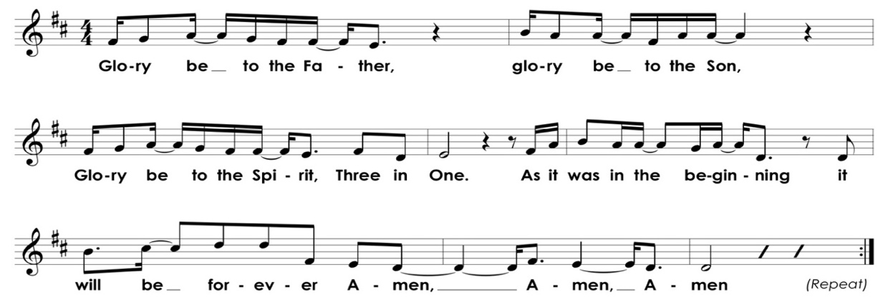
*Gloria Patri

*Affirmation of Faith Apostles' Creed
I believe in God the Father Almighty, Maker of heaven and earth, and in Jesus Christ his only Son our Lord; who was conceived by the Holy Ghost, born of the Virgin Mary, suffered under Pontius Pilate, was crucified, dead, and buried; He descended into hell; the third day He rose again from the dead; He ascended into heaven, and sitteth on the right hand of God the Father Almighty; from thence He shall come to judge the quick and the dead. I believe in the Holy Ghost; the holy catholic church; the communion of saints; the forgiveness of sins; the resurrection of the body; and the life everlasting. Amen.

ANNOUNCEMENTS
Meet a Member: Genevieve Butler & Sally McDuffie introduced by Cathy Hinson
Meredith, Joey, & Caleigh Mosny

PRESENTATION OF TITHES AND OFFERINGS

Offertory Anthem “Northfield” Jeremiah Ingalls
Southern Harmony, 1835
How long, dear Savior, oh! how long Shall that bright hour delay;
Fly swiftly round, ye wheels of time and bring the welcome day!

From the third heaven, where God resides, That holy, happy place,
The new Jerusalem comes down, adorned with shining grace.

The God of glory down to men, Removes His blest abode.
Men, the dear object of His grace, and He the living God!
*Doxology Old Hundredth
Praise God from whom all blessings flow, praise Him all creatures here below.
Praise Him above, ye heavenly host, praise Father, Son and Holy Ghost.

*Prayer of Dedication
Dear God, from whom all life comes, we bring you what is yours. We bring you everything - our money, our time, our talents, or our limitations, our brokenness. We ask that you transform that which we bring, that which we are to what you would have us be. Use us for your good purpose and for your glory alone. Amen

Time for Children Sarah Craven
Litany of Parting: Children: May God be with you here. Congregation: May God be with you there.
Children under 6 are welcome to the nursery; children age 6-10 are invited to the Chapel for Children's Choir

*Hymn O Great God see insert

Pastoral Prayer of the People
PROCLAIMING THE WORD

First Scripture Reading Jeremiah 29: 1, 4-7 Page 731
Second Scripture Reading Luke 17: 11-19 Page 80

Sermon THE PRINCE OF EMOTIONS Rev. Cress Darwin

*Closing Hymn Leaning on the Everlasting Arms #837

*Benediction and Choral Response Amen Danish

Postlude Prelude and Fugue in Bb JS Bach

*Please stand, as you are able. Hearing aids and large-print hymnals are available at the back of the sanctuary.

INFORMATION/ANNOUNCEMENTS

SeCond family PrayerS – Merritt Tenpas, Allston Kitchens, Charlie Girard, McKenzie Girard, Denise Girard, David McEachern, Kay McGaha, Virginia Harding, Winkie Welborn, Bill Thompson, Maria Fitzharris, and Courtney Waring.

SECOND SUNDAY LUNCH – Join us today for an Italian meal featuring traditional meat lasagna, eggplant parmesan, classic meatballs, an assortment of salads, and desserts including tiramisu. All are welcome! Suggested donation of $5/ person or $10/ family; donation basket can be found on the serving island.

HIGHLIGHTS from last week's music by the Charleston Gospel Choir can be found on our church website:
http://www.2ndpc.org/blog or http://www.2ndpc.org/music

CONCERTS COMING UP AT SECOND: Thursday, Oct. 24, 7:30 pm, College of Charleston Concert Choir, directed by Dr. Robert Taylor; Dr. Julia Harlow pianist/organist.

"FRENCH IMPRESSIONS" concert, Friday, Nov. 1, 7:30 pm, Matthew Swingle, organ instructor at Charleston
Southern University, and Dr. Julia Harlow, will present a concert called "French Impressions" - French organ music of the 17th - 21st centuries, on our sanctuary organ.

BOOK CLUB – This month we are reading David MacCullough's The Pioneers. This is a well-researched and well told story of New Englanders who crossed into the new Ohio Territory beginning in the 1790s. Meeting at the Schuh’s on October 15th at 6:30 p.m.

BEAUTIFY THE YARD DAY – Join us for the next Beautify the Yard Day on October 26th from 9:30-noon. We’ll work together in fellowship cleaning the church yard. Please bring leaf bags, rakes, and leaf blowers if you have them. Kids are welcome!

TRUNK-OR-TREAT – Come for our 3rd annual Trunk-or-Treat Night, Sunday, October 27th from 5-7p.m. Bring your kids for an extra excuse to don their costume! This will be a fun evening of intergenerational food and fun, so whether or not you have kids dressing up, please come for dinner and decorate your car and be part of the evening of fun and fellowship. Peanut-free candy and small toy donations are needed and can be dropped off in the donation box in the education building. Please sign up or contact Sarah Craven if you’ll be able to decorate your car for the Trunk-or-Treating.

BETHELWOODS – The Middle School Presbytery Retreat at Bethelwoods is Nov. 8-10th. Contact Sarah for more info.

SPK FALL FESTIVAL – Our preschool will host their annual Fall Festival Sunday, November 10th from 4-6 p.m. The event is open to everyone! Come for games, food and family fun!

Community thanksgiving – All are invited as we come together for a Community Thanksgiving Service and Supper on Tuesday, November 26th. The service will start at 7:00 p.m. and supper will follow. This is an annual time of community as area churches come together in our sanctuary in a collaborative evening of thanksgiving and worship. Invite your friends and neighbors!

MIDWEEK BIBLE STUDIES – Different groups meet throughout the week for bible studies and fellowship upstairs in the conference room. A group of women are going through the Beth Moore study Entrusted on Wednesdays at 6:00 p.m. A morning women’s study on Thursdays at 9:00 a.m. is currently discussing Desperate: Hope for the Mom Who Needs to Breathe. Men meet early Fridays at 6:00 a.m. to discuss the book Wild at Heart by John Eldridge. Please contact Sarah if you are interested in a joining or leading a bible study group.

WHAT IS YOUR TREASURE? Join your Second Family as we commit our treasure in service to the Lord by pledging your 2020 gift this Stewardship season. When you enter into a partnership with the body of Christ, you are not only building up treasure for this generation but also for generations to come. Pledge cards can be placed in the offering plate or delivered to the church office- or make your pledge online at www.2ndpc.org/pledge.

SUNDAY, October 13
Second Sunday Lunch
9:00 a.m. – Breakfast
9:30 a.m. – Sunday School
10:30 a.m. – Worship Service
MONDAY, October 14
Holiday – Church Office Closed
TUESDAY, October 15
6:00 a.m. – Body Pump
5:30 p.m. – Spiritual Ensemble Rehearsal
6:30 p.m. – Book Club
WEDNESDAY, October 16
5:00 p.m. – Bell Choir Rehearsal
6:00 p.m. – Women’s Bible Study
6:30 p.m. – Choir Rehearsal
THURSDAY, October 17
6:00 a.m. – Body Pump
9:00 a.m. – Moms’ Bible Study
FRIDAY, October 18
6:00 a.m. – Men’s Bible Study
SATURDAY, October 19
11:00 a.m. – Sisters in Serenity Group
SUNDAY, October 20
9:00 a.m. – Breakfast
9:30 a.m. – Sunday School
10:30 a.m. – Worship Service
Looking ahead…
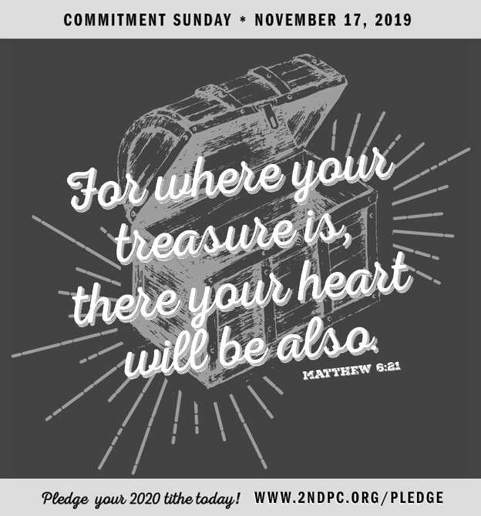

Cress Darwin, Pastor
cdarwin@2ndpc.org
Sarah Craven, Director of Christian Education, sarah.craven@2ndpc.org
Dr. Julia Harlow, Director of Music
jharlow@2ndpc.org
Lee Lingle, Chancel Choir Director
leelingle3@gmail.com
Clarissa Rider, Children’s Choir Director
clarissa.rider@gmail.com
Suzann Lilienthal, Administrator
suzann.lilienthal@2ndpc.org
Jordyn Pritchard, Communications
jordyn.pritchard@2ndpc.org
Annie Ravenel, Housekeeping
Tina Smith, Elder of the Month
SaSa Darwin, Liturgist
Nicole Schuerman, Greeter
Sue Henderson, Director of Kindergarten
Erin Kerr, Asst. Director of Kindergarten
Women’s Bible Study, sueatsecond@gmail.com
Moms’ Bible Study, marydriver11@gmail.com
Men’s Bible Study, aledpritchard@gmail.com
Irina Pevzner, Charleston Academy of Music charlestonacademyofmusic@gmail.com
Lee Pringle, Charleston Gospel Choir
lee@colourofmusic.org

COMMITTEES
Aled Pritchard, Christian Education
Chuck Medbery, Finance
Sarah Mitchell, Missions
Nathan Walker, Music & Worship
Rob McCready, Property

Elinor Fox
Jason Lind
Nick Roddey
Mary Fetscher
Nathan Walker
Amber Briggs-Most
Dawn Dubs
Jay McDonald
Sally Caithness
Frank Schmidt
Ella Bailey
Donald Accardo
Agnes Kling
Georgia Powell
Laura Taylor
Jim Kettering
Meg McElwaine
Jay Stevens
Bebe Coyle
George J. Howe
Caroline Smith
Trey Skinner
Chris Craven
Celeste McMaster
Pat Garrett
Craig Baumer
Peter Rupert
Donald Howe, Jr.
Anna Derrick
Buist Smythe

1st
2nd
3rd
3rd
4th
4th
5th
5th
6th
8th
8th
8th
8th
10th
11th
15th
15th
15th
16th
16th
18th
19th
21st
22^{n}
24th
25th
26th
27th
27th
28th

FINANCIAL SNAPSHOT*

 | Actual | Budget
Income | $280,645.28 | $358,453.27
Expenses | $376,492.93 | $415,056.69
 | -$ 95,847.65
Pledge Campaign | $257,618.00 | $270,000.00
Steeple Fund | $62,525.00 | $100,000.00

*as of October 5, 2019

Second Presbyterian church 342 meeting street, Charleston, SC 29403 843.723.9237. WWW.2NDPC.ORG/events

